**8. Appendices**

**8.1 Appendix A: Process of using the CMS**

**1. Creating a site**

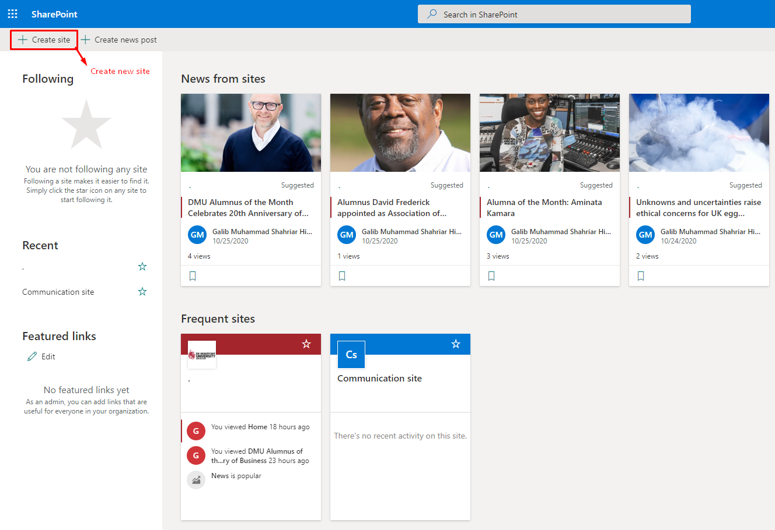

Figure 1: Create site.

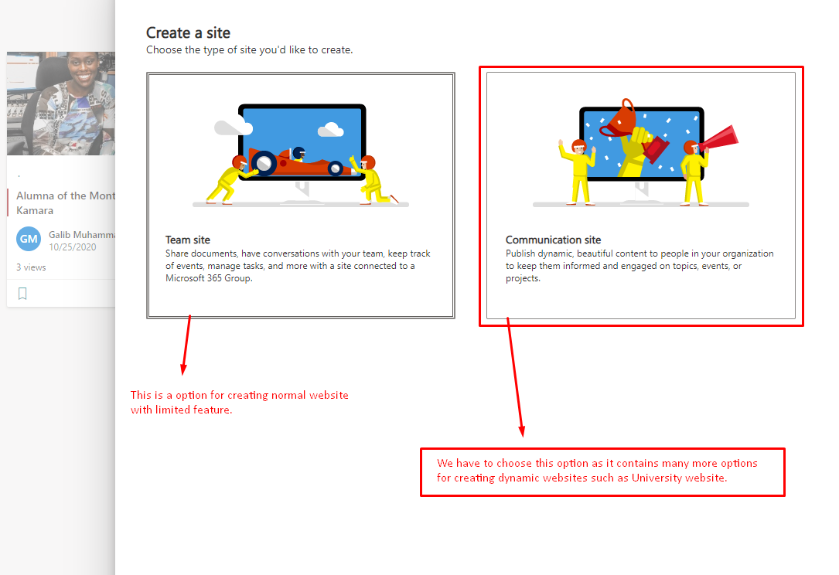

Figure 2: Select communication site.

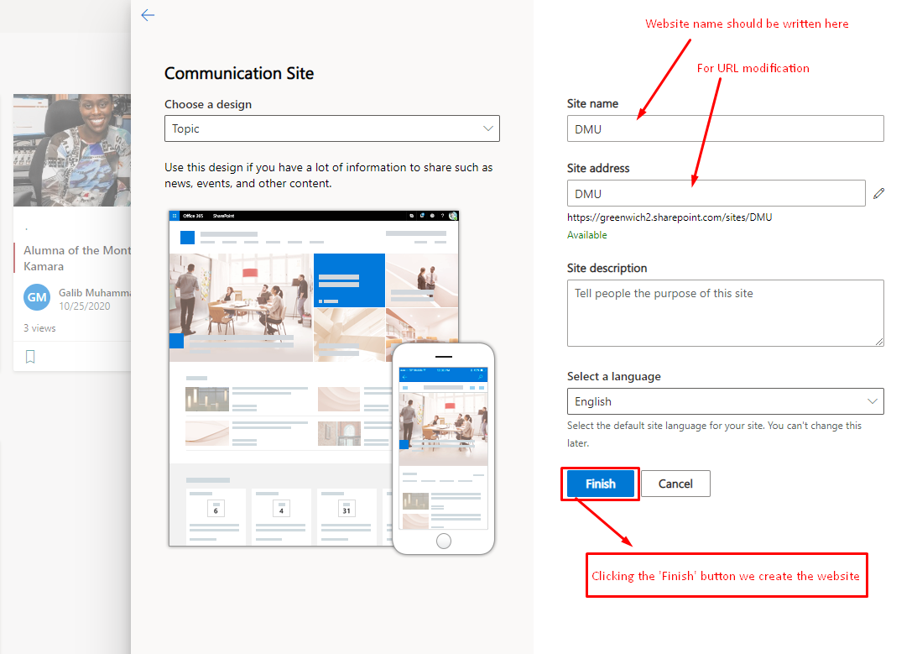

Figure 3: Select site name and address.

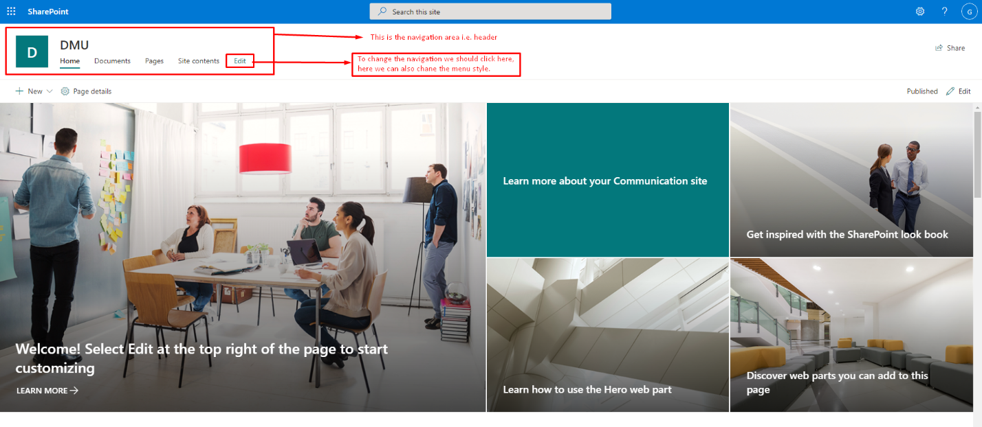

Figure 4: Edit navigation bar.

**2. Adding a page and content in the site**

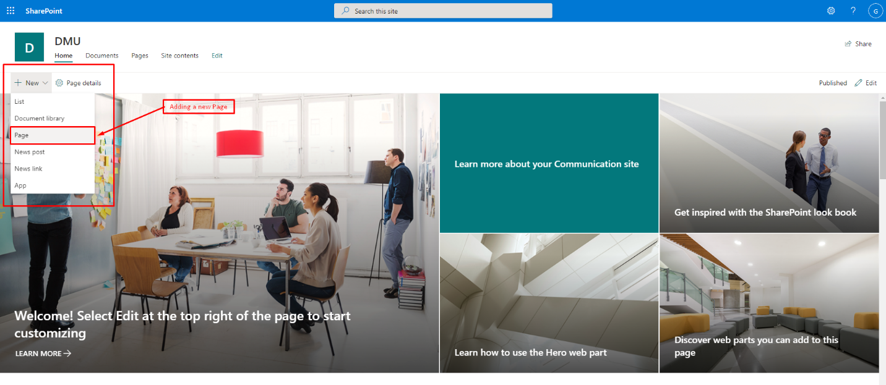

Figure 5: Create new page.

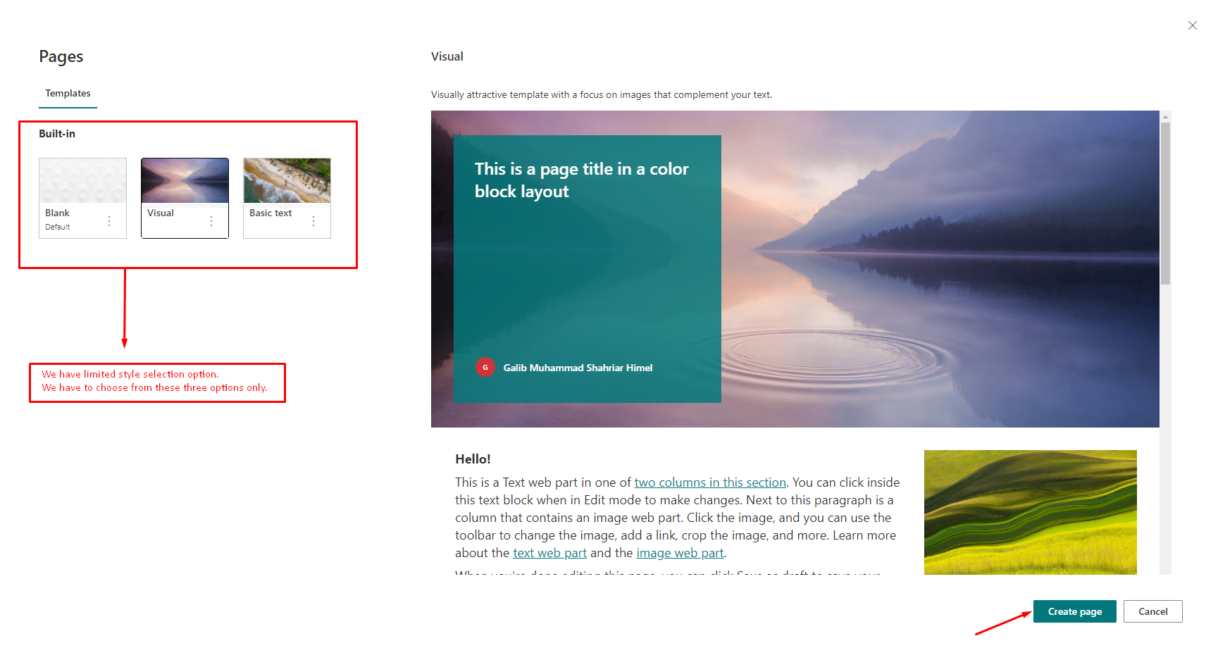

Figure 6: Select page template.

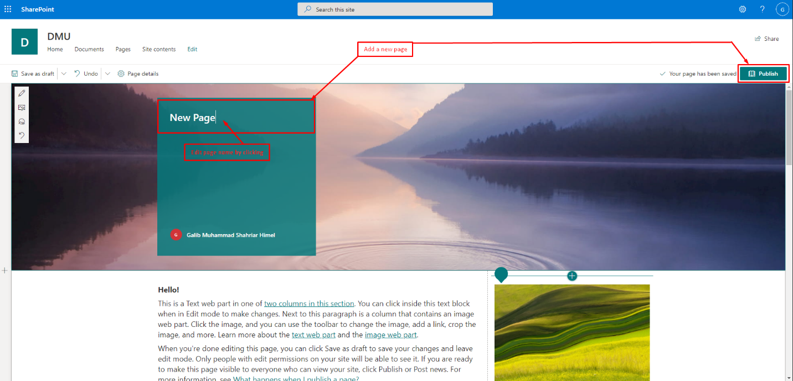

Figure 7: Write page name.

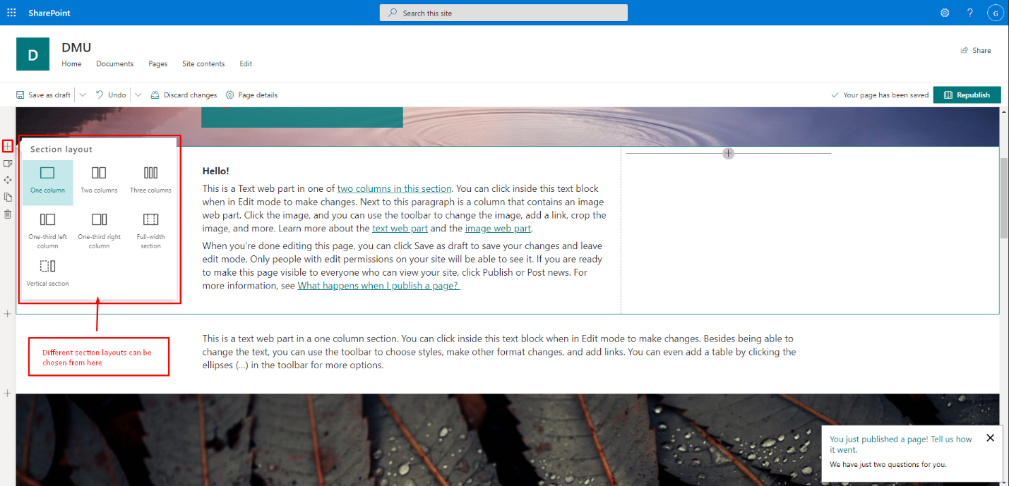

Figure 8: Add section.

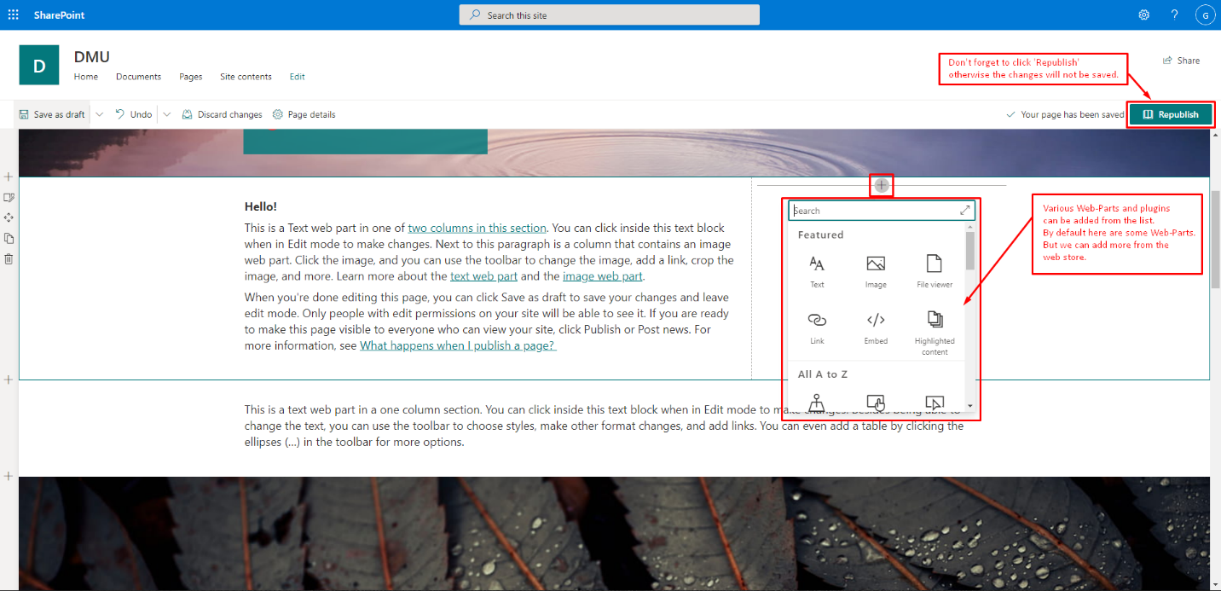

Figure 9: Add web part.

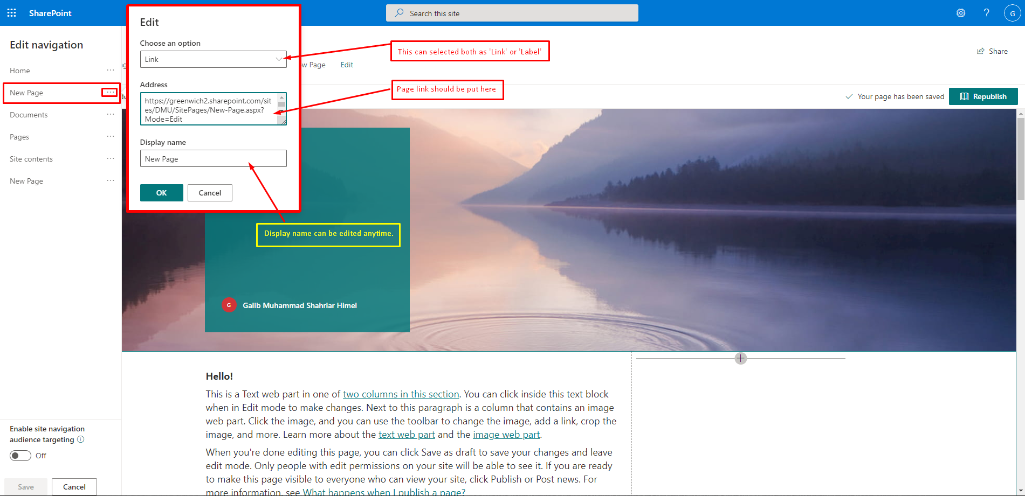

Figure 10: Add link to menu in navigation.

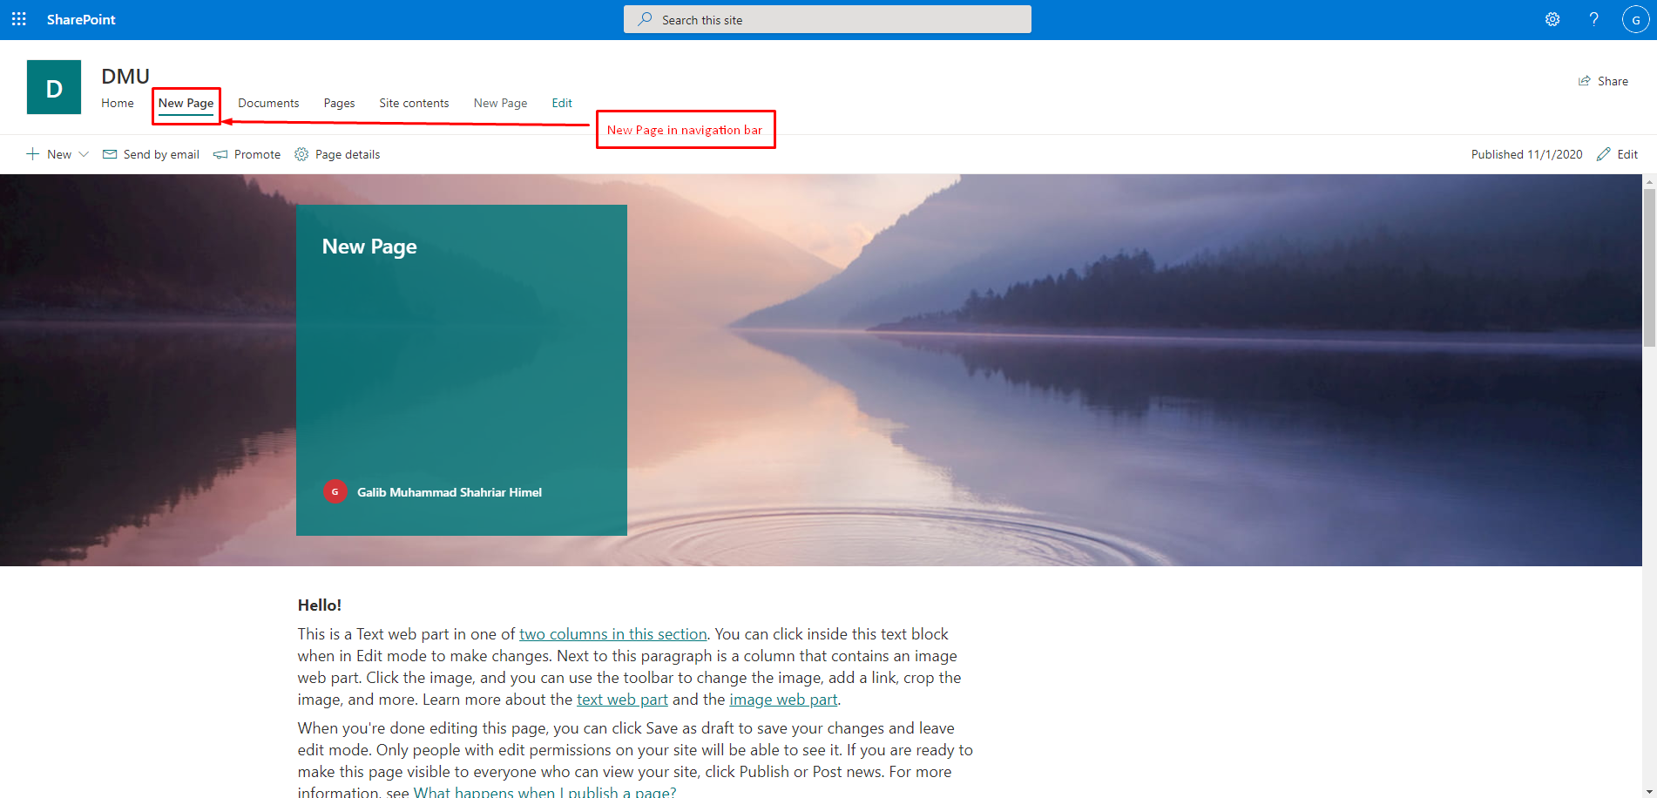

Figure 11: Showing new menu.

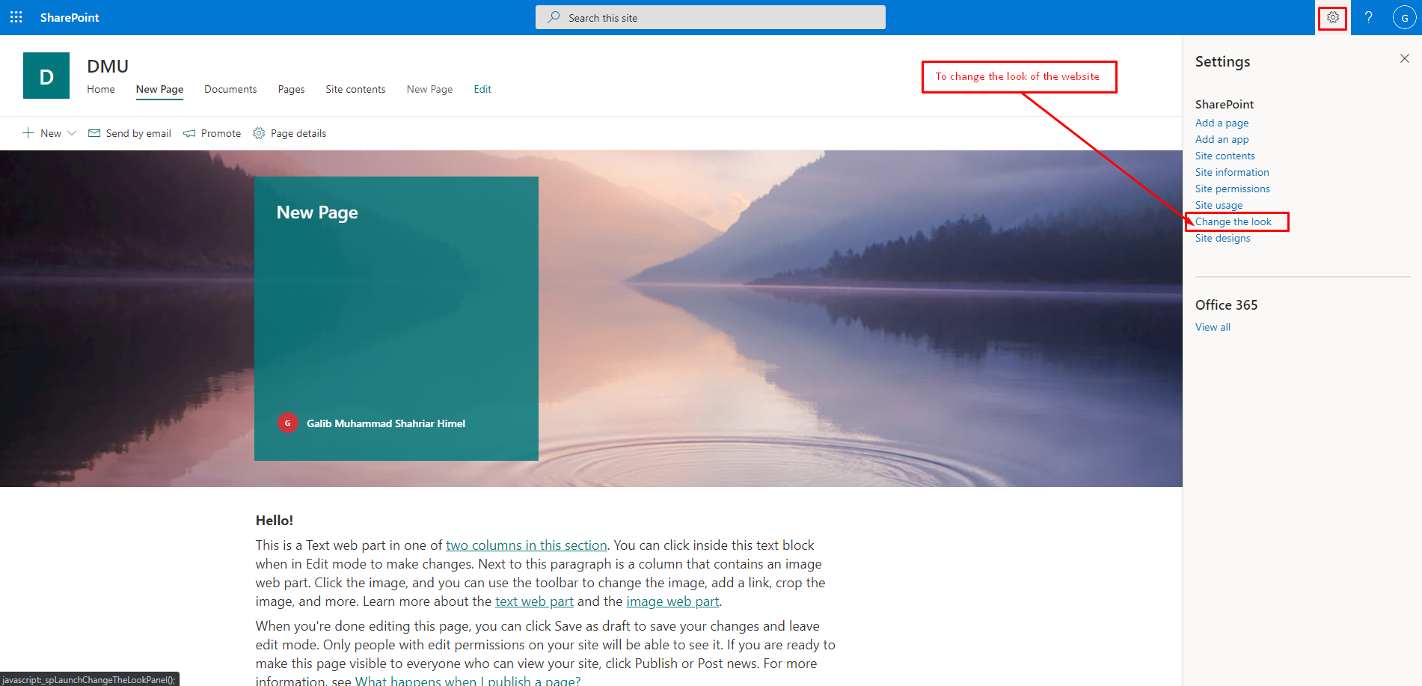

Figure 12: Change look.

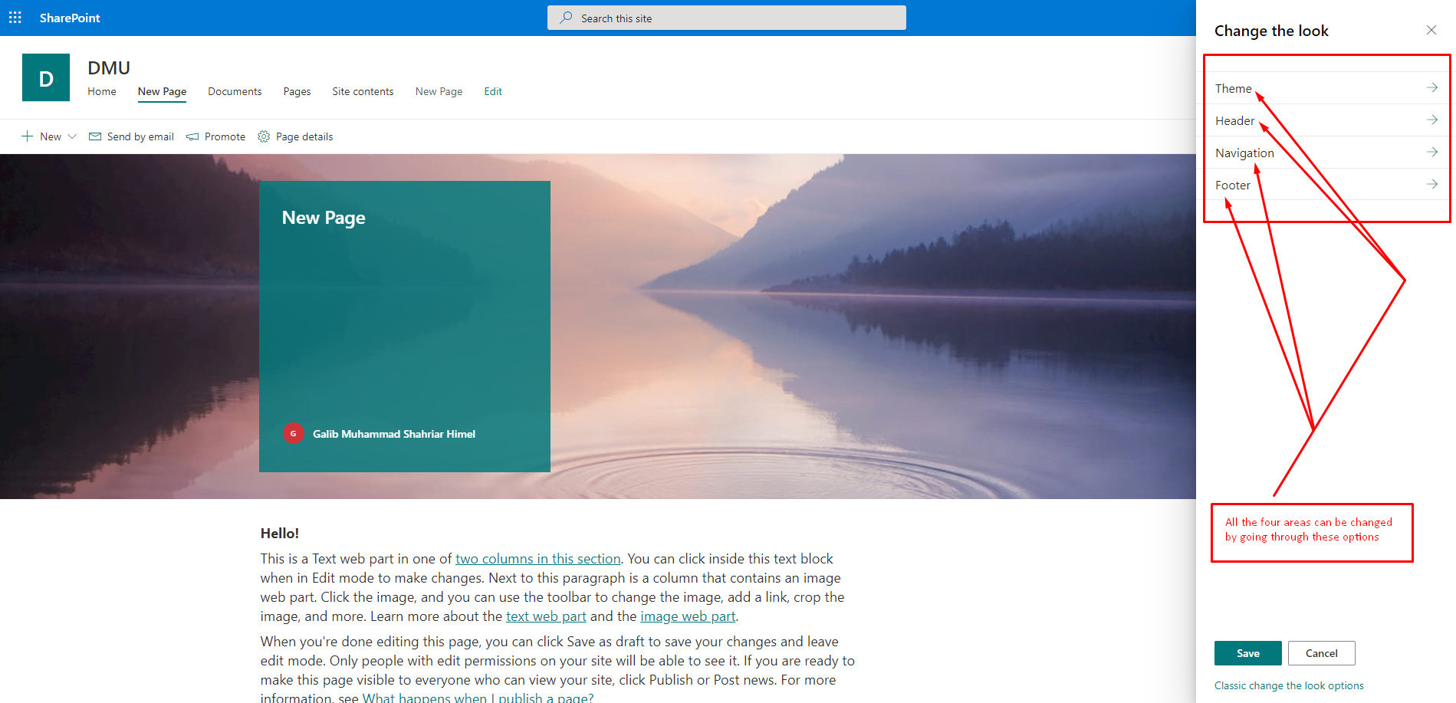

Figure 13: Change theme, header, footer.

**3. Adding a list into the CMS site:**

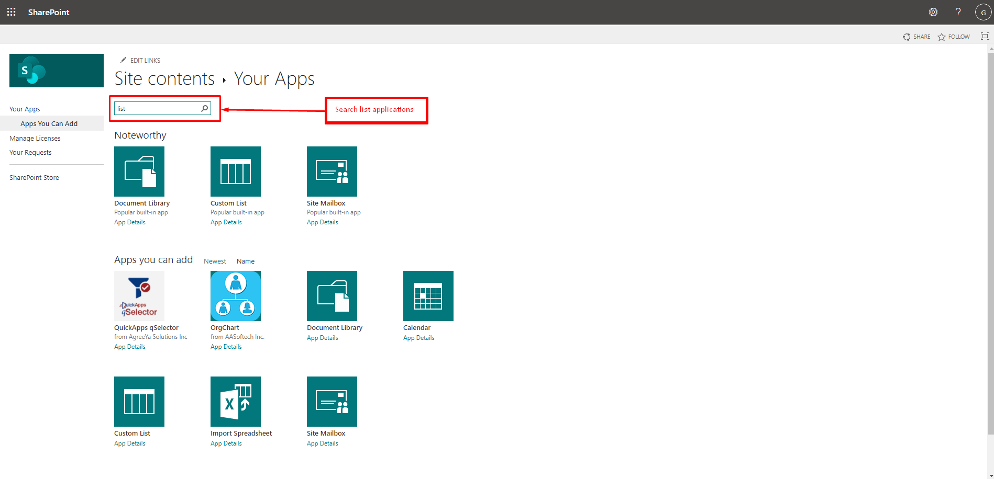

Figure 14: Add a new list.

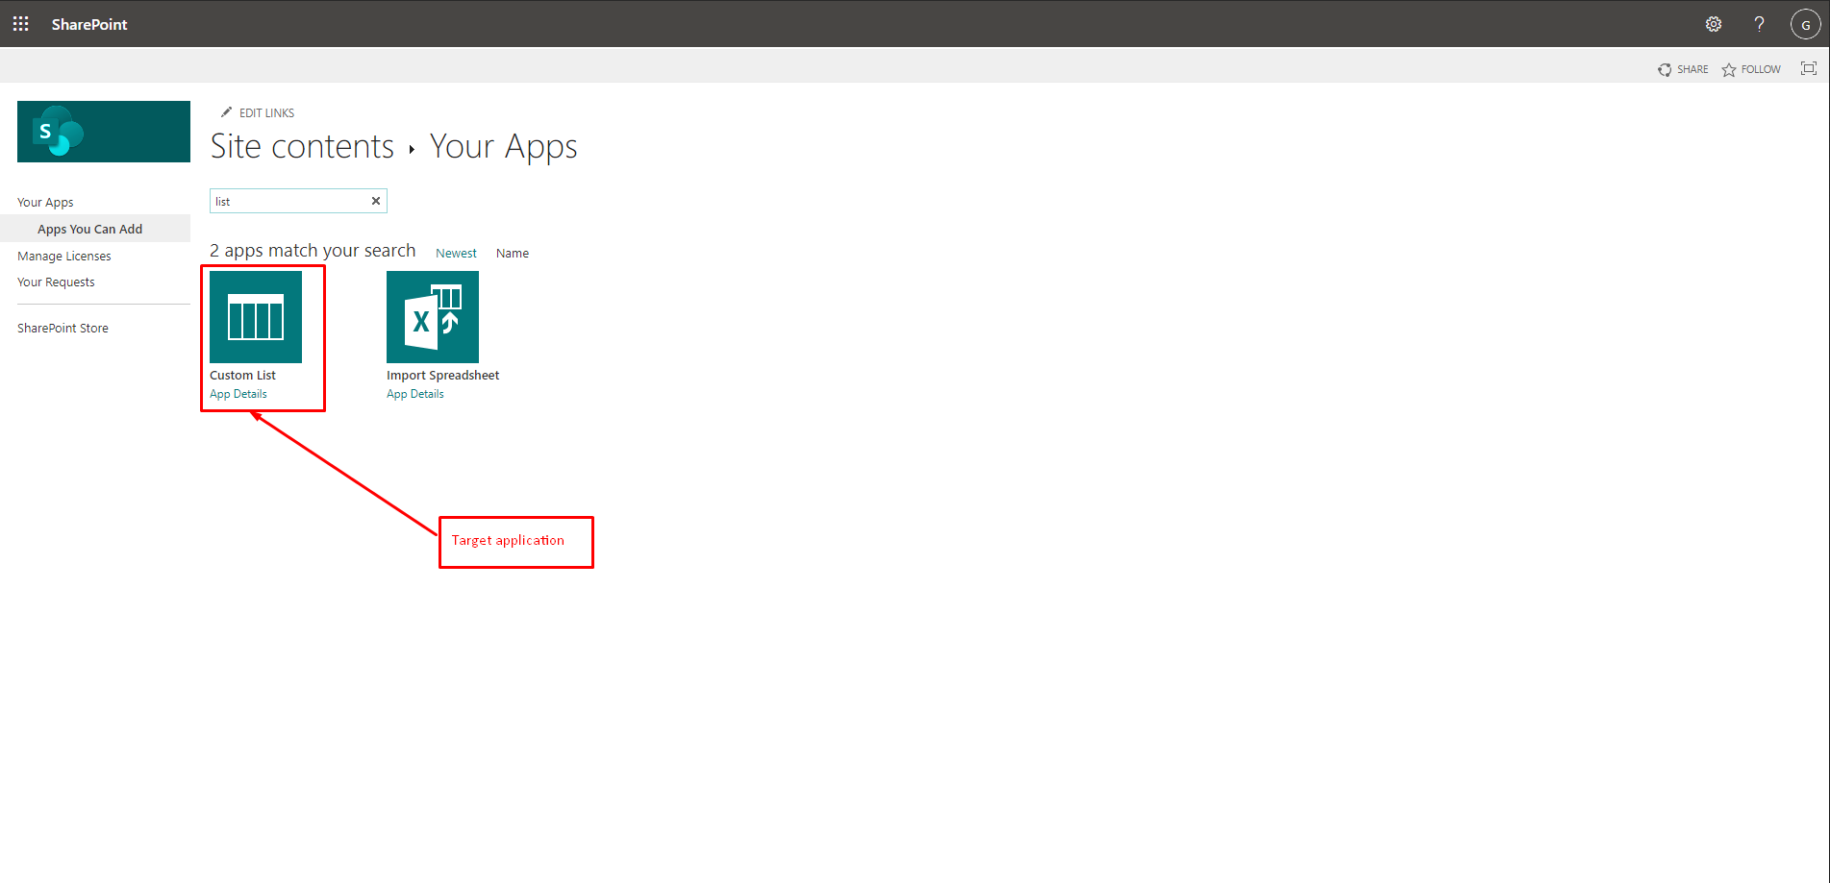

Figure 15: Select custom list.

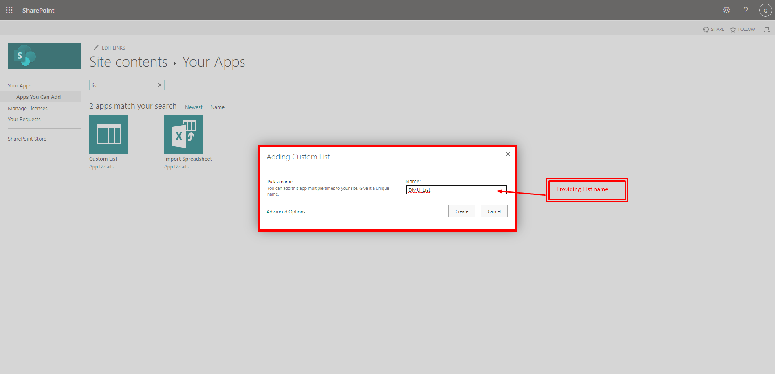

Figure 16: Give name to the list.

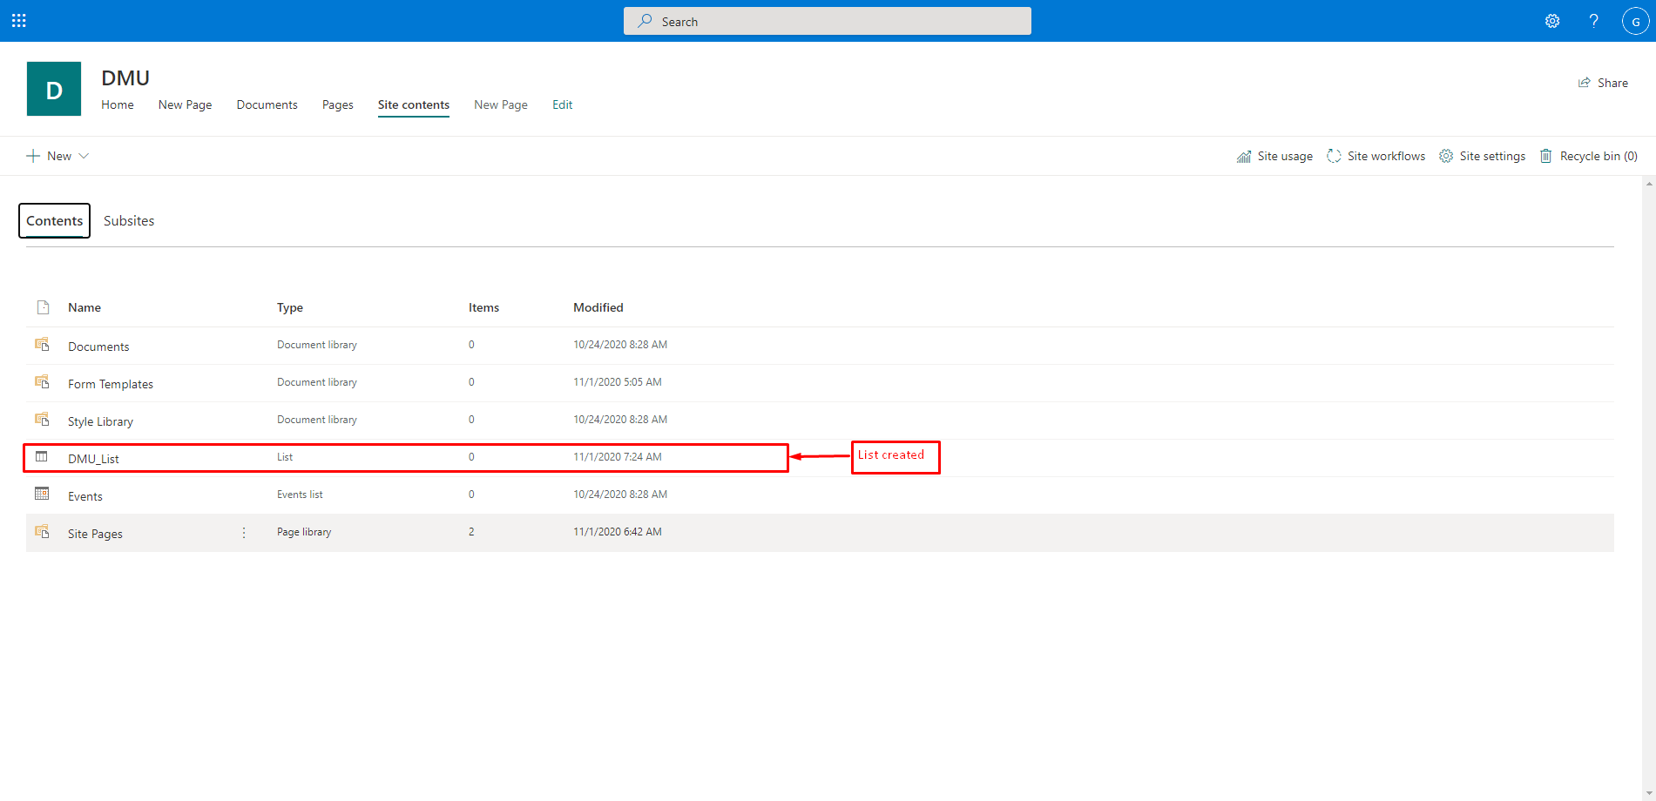

Figure 17: List crated.

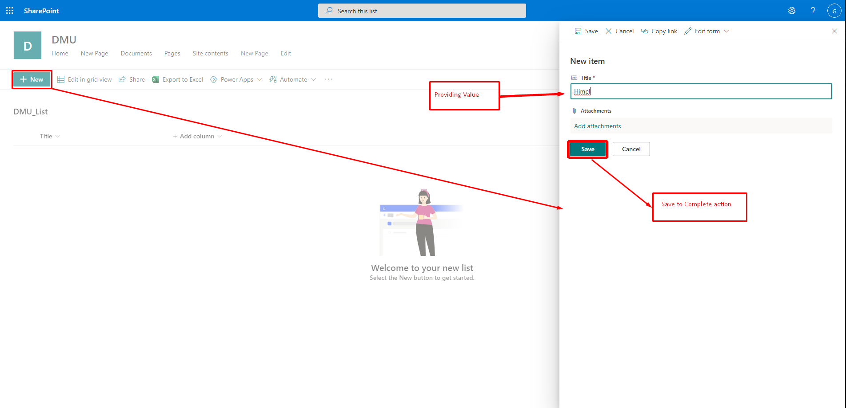

Figure 18: Add new item.

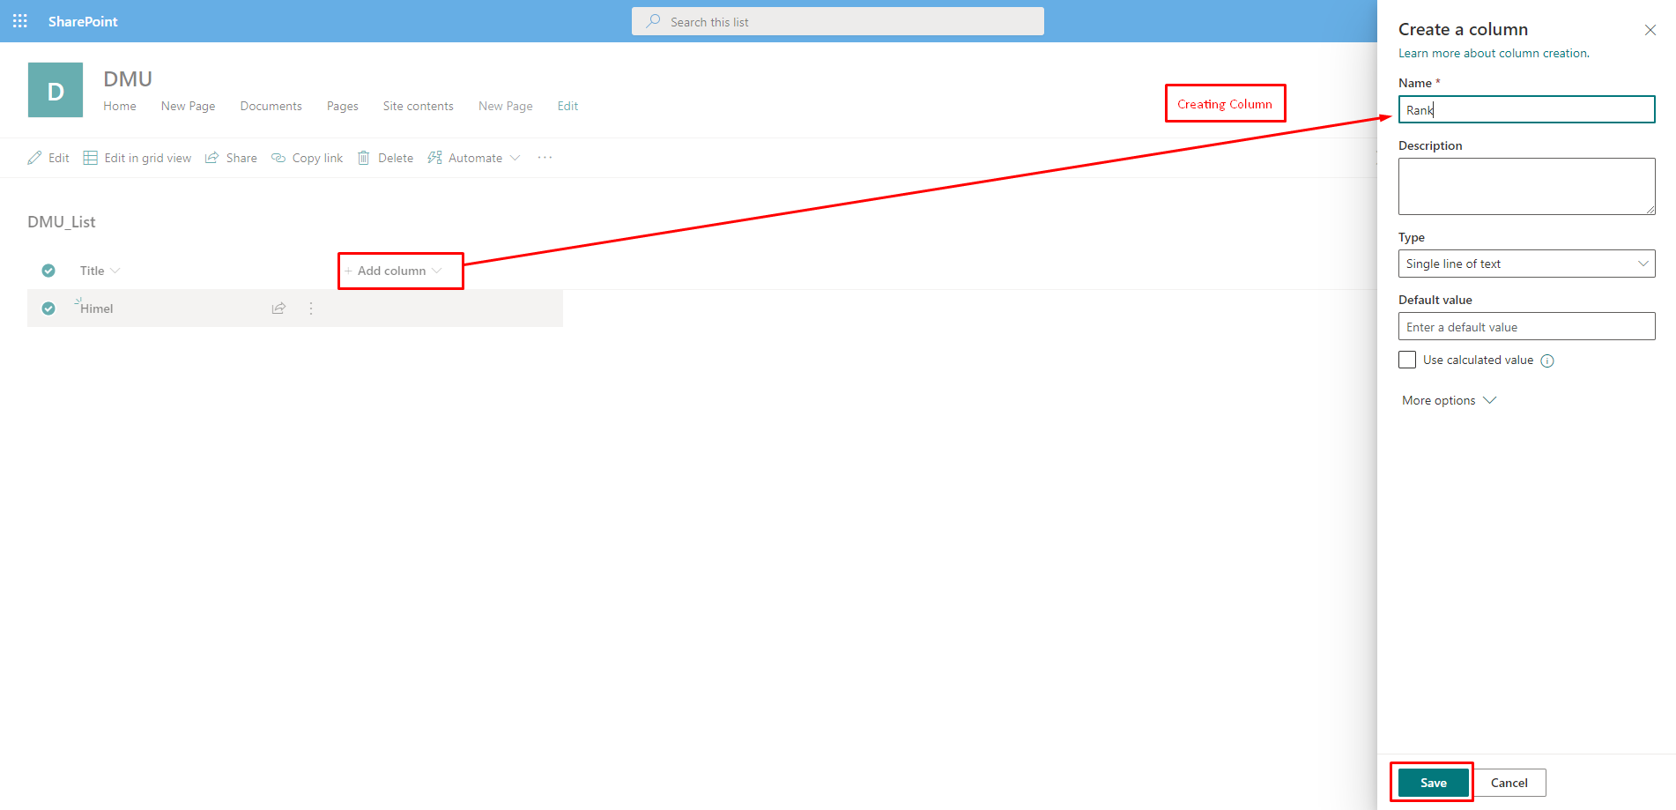

Figure 19: Enter name.

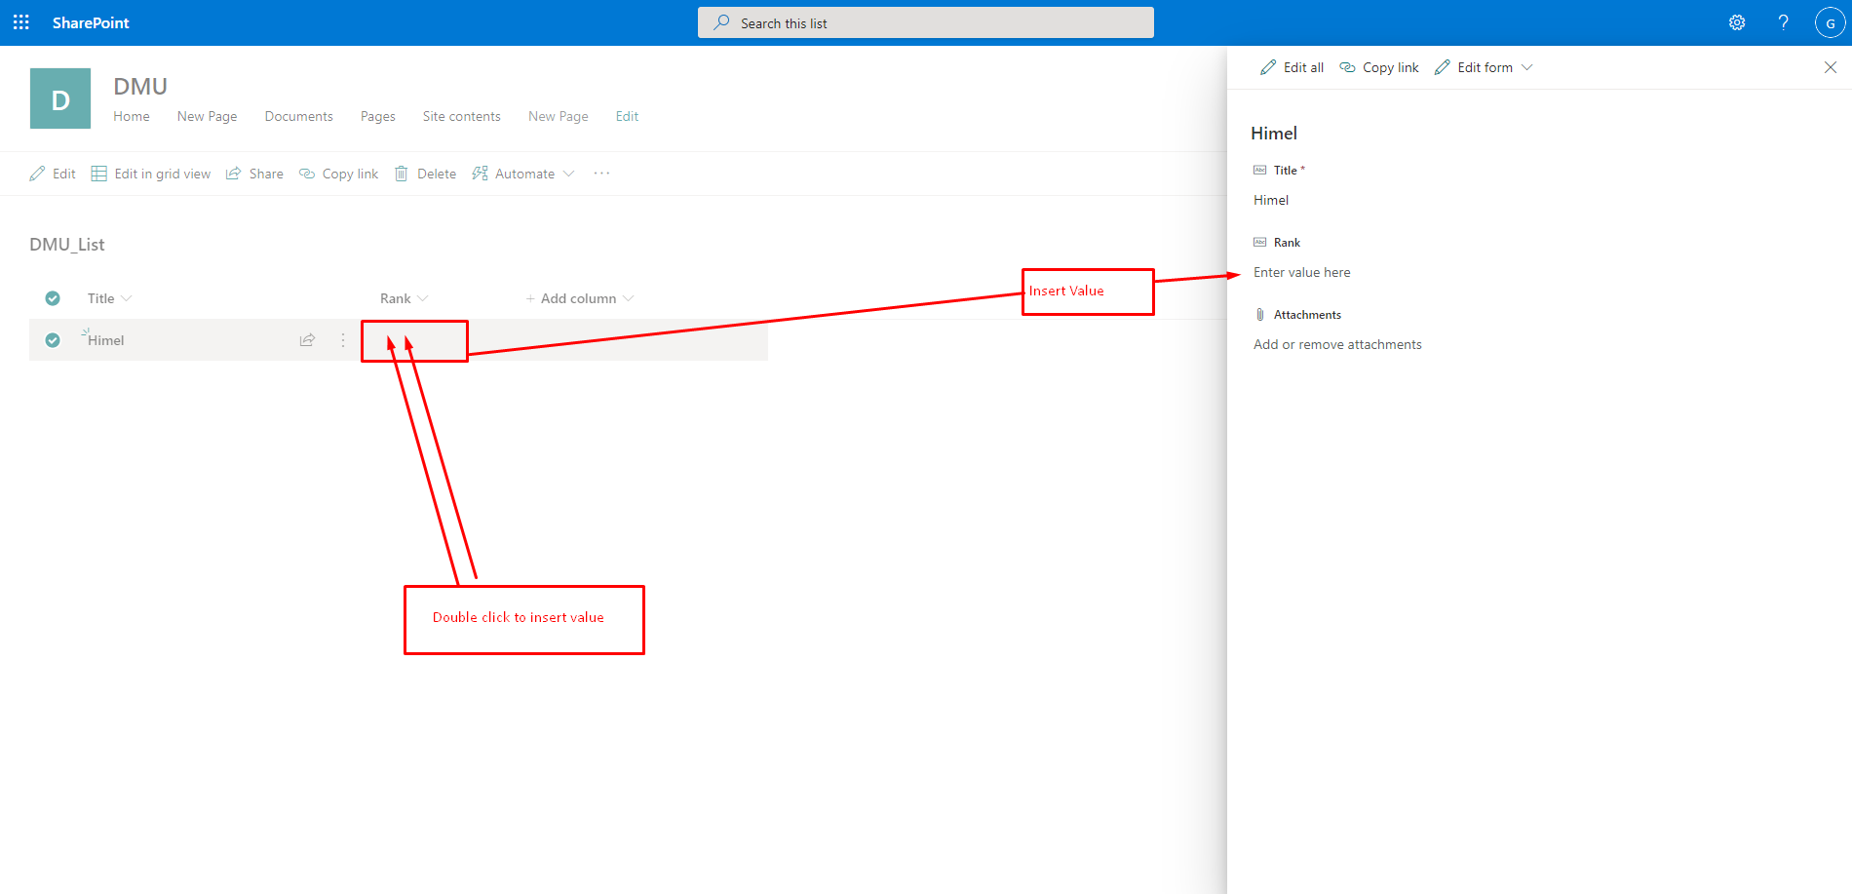

Figure 20: Insert value.

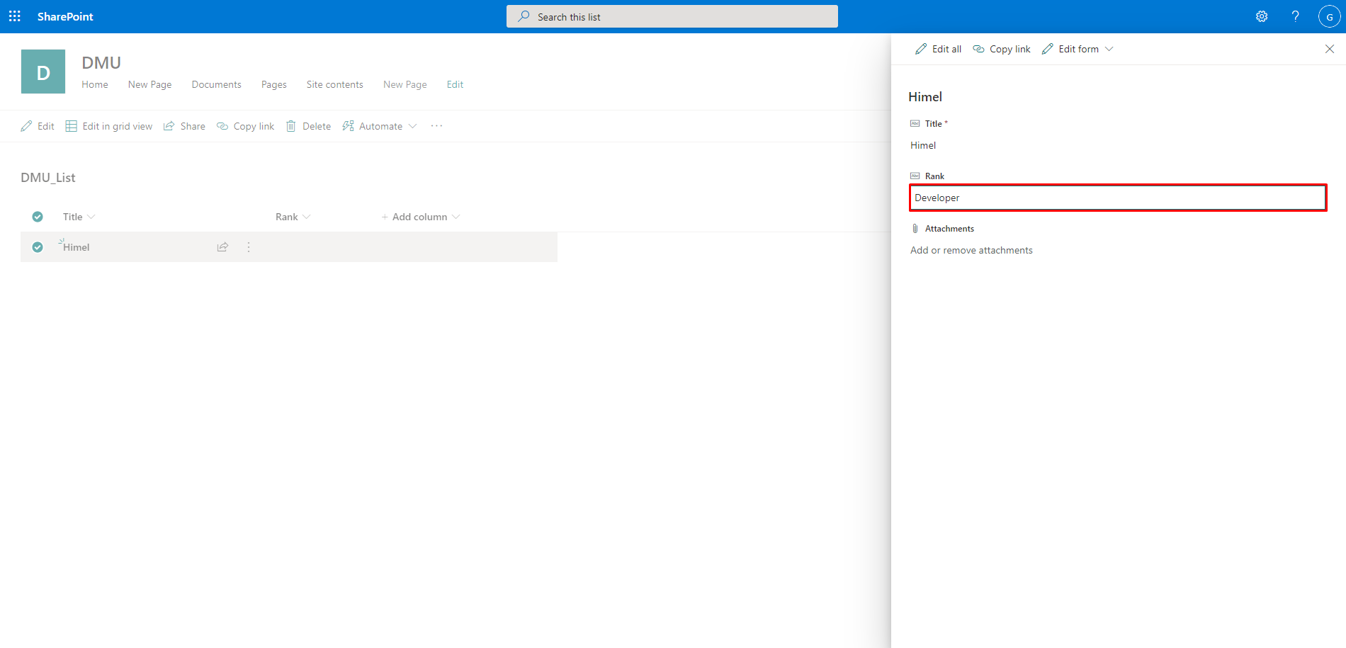

Figure 21: Insert value (2).

**4. Creating a document library and uploading documents**

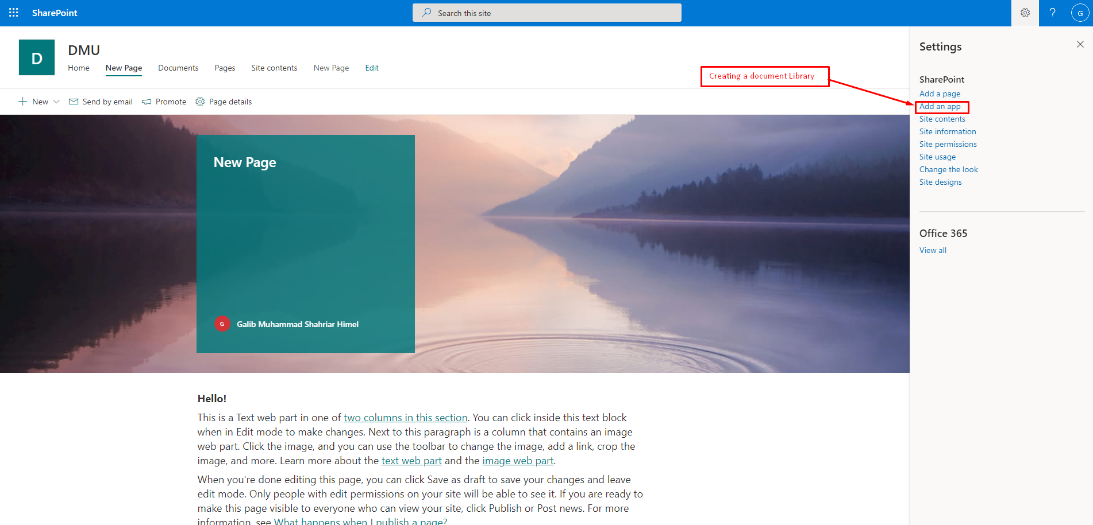

Figure 22: Create document library.

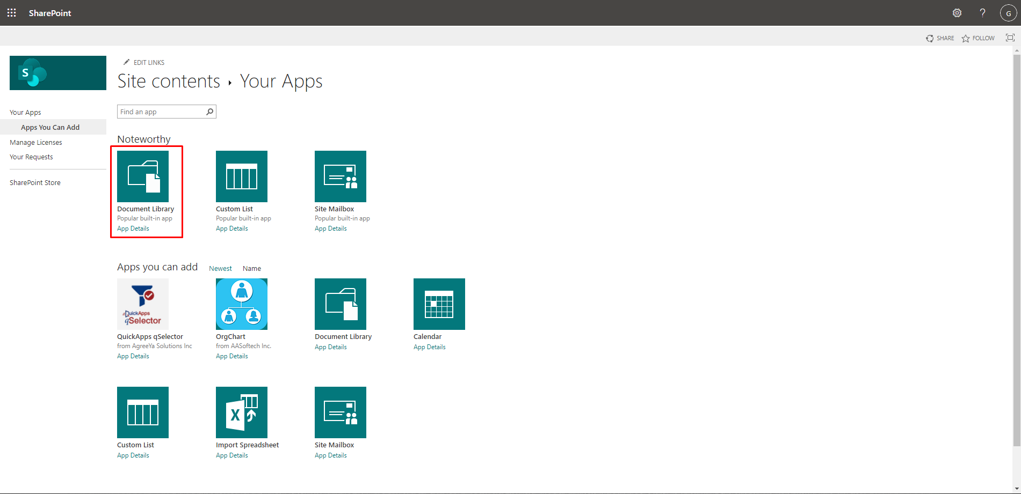

Figure 23: Select document library.

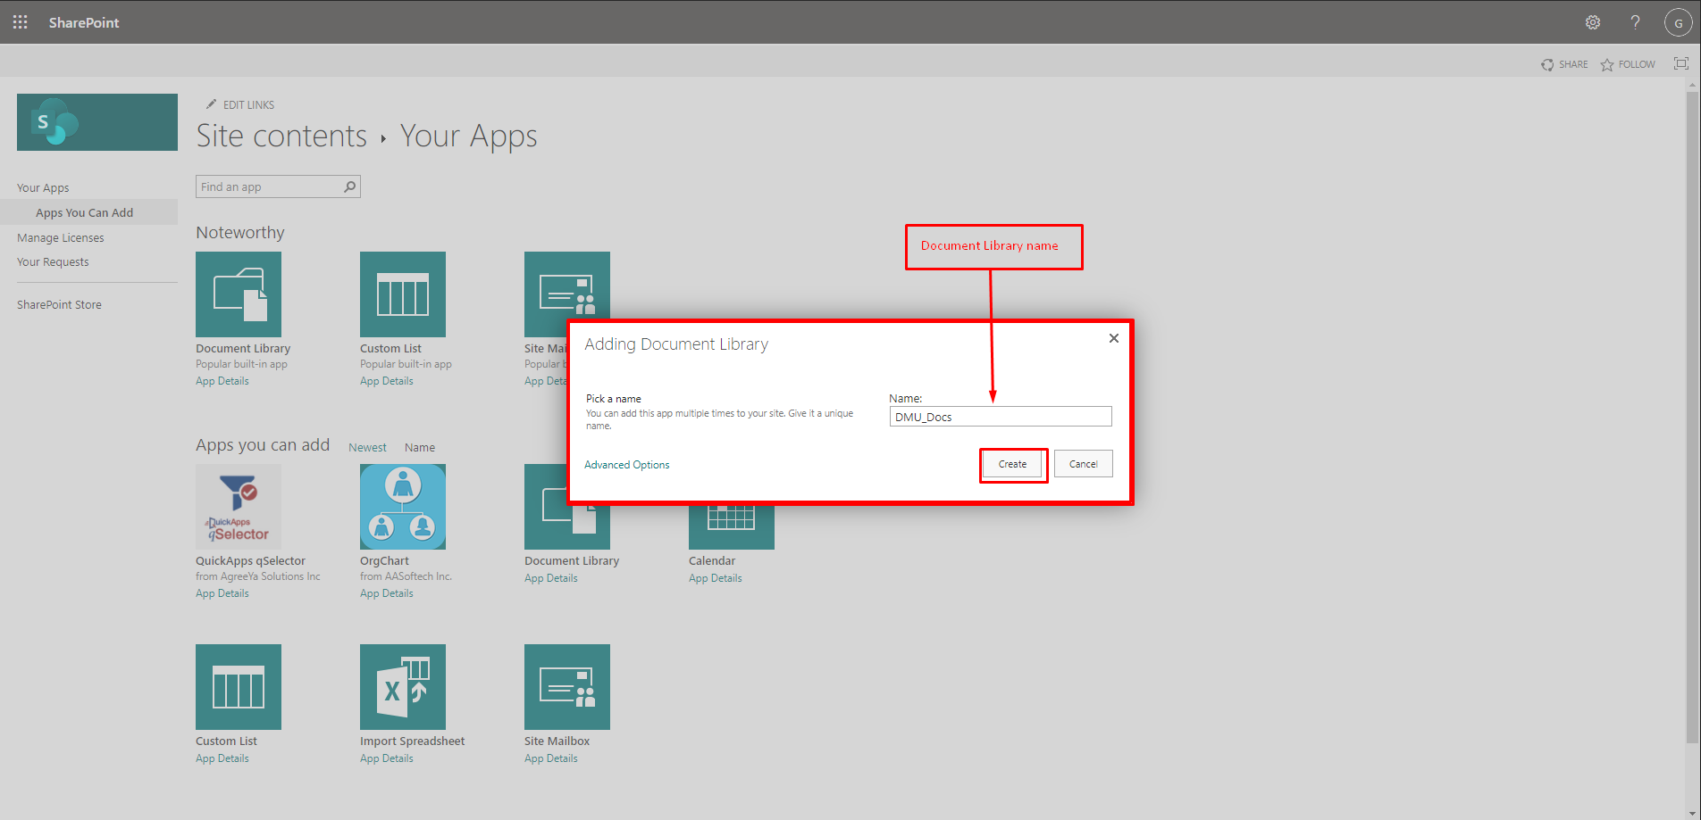

Figure 24: Give document library name.

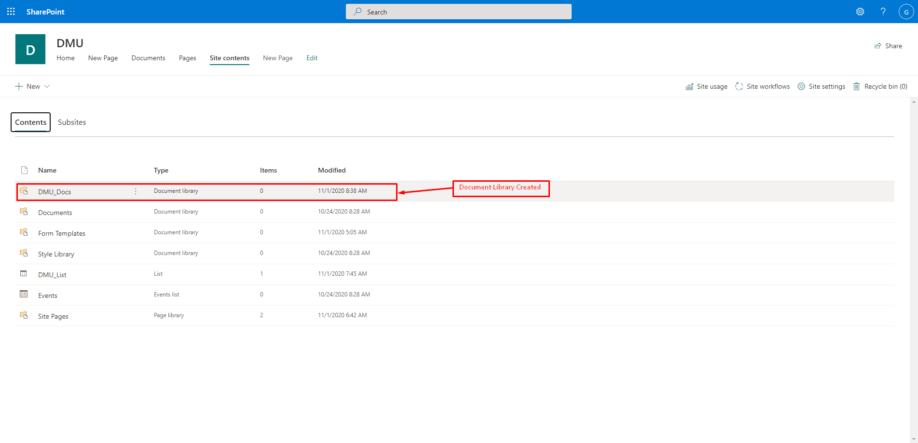

Figure 25: Document library created.

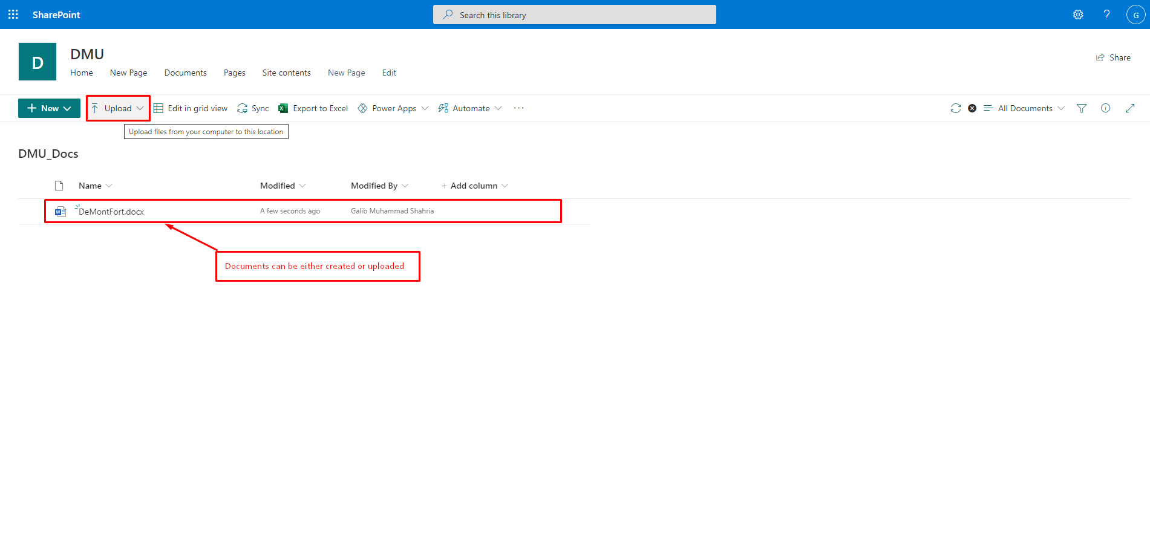

Figure 26: Upload document.

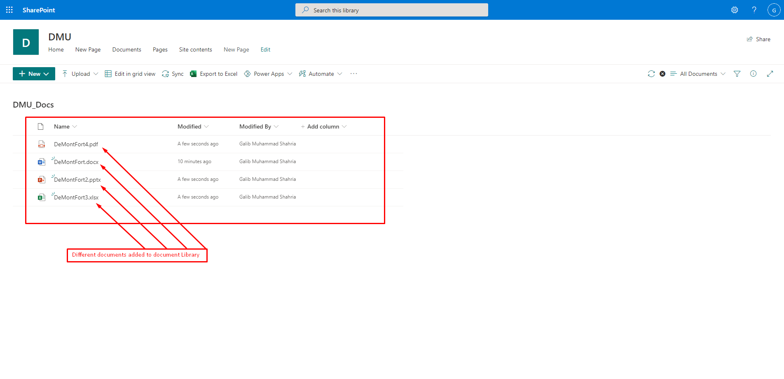

Figure 27: Different documents uploaded.

**5. Adding new user and defining role**

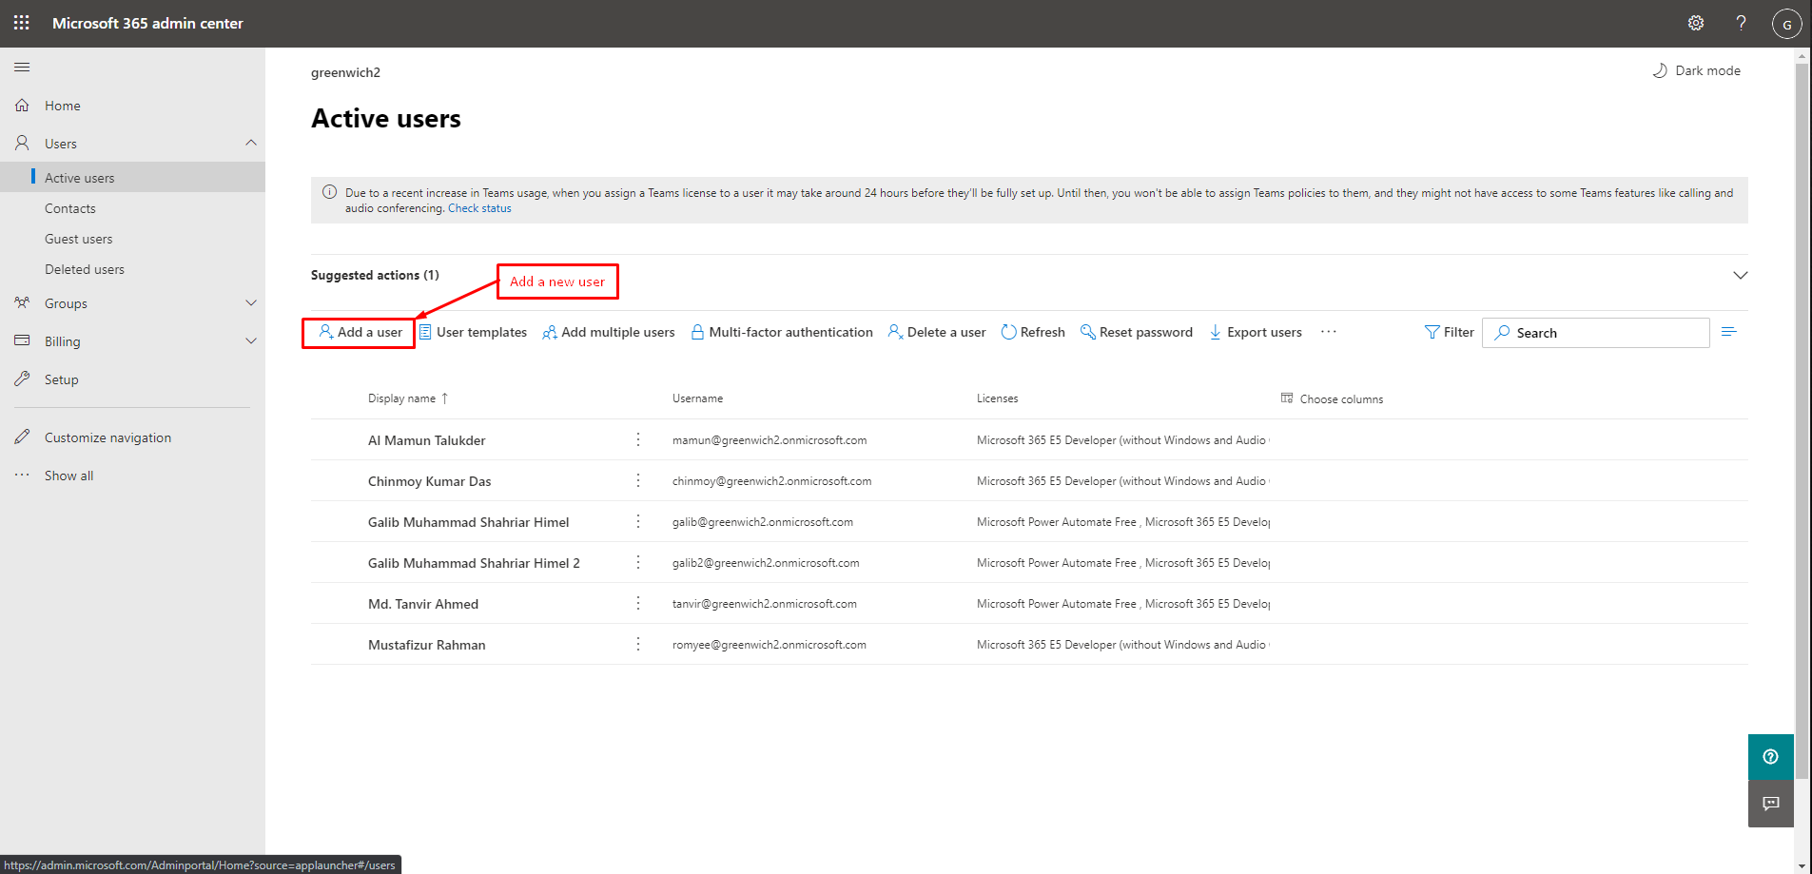

Figure 28: Add new user.

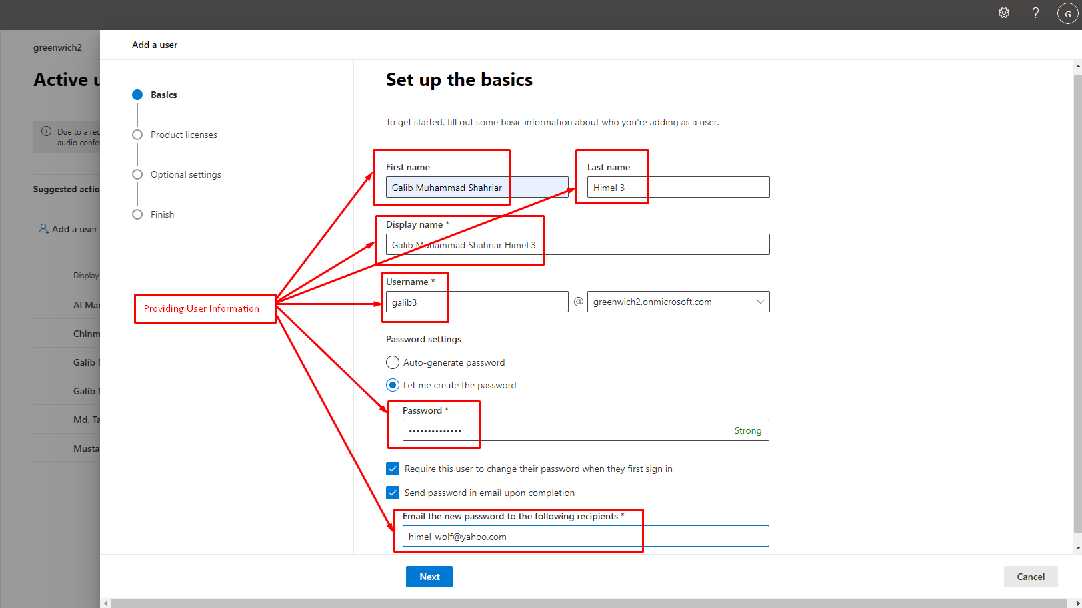

Figure 29: provide user info.

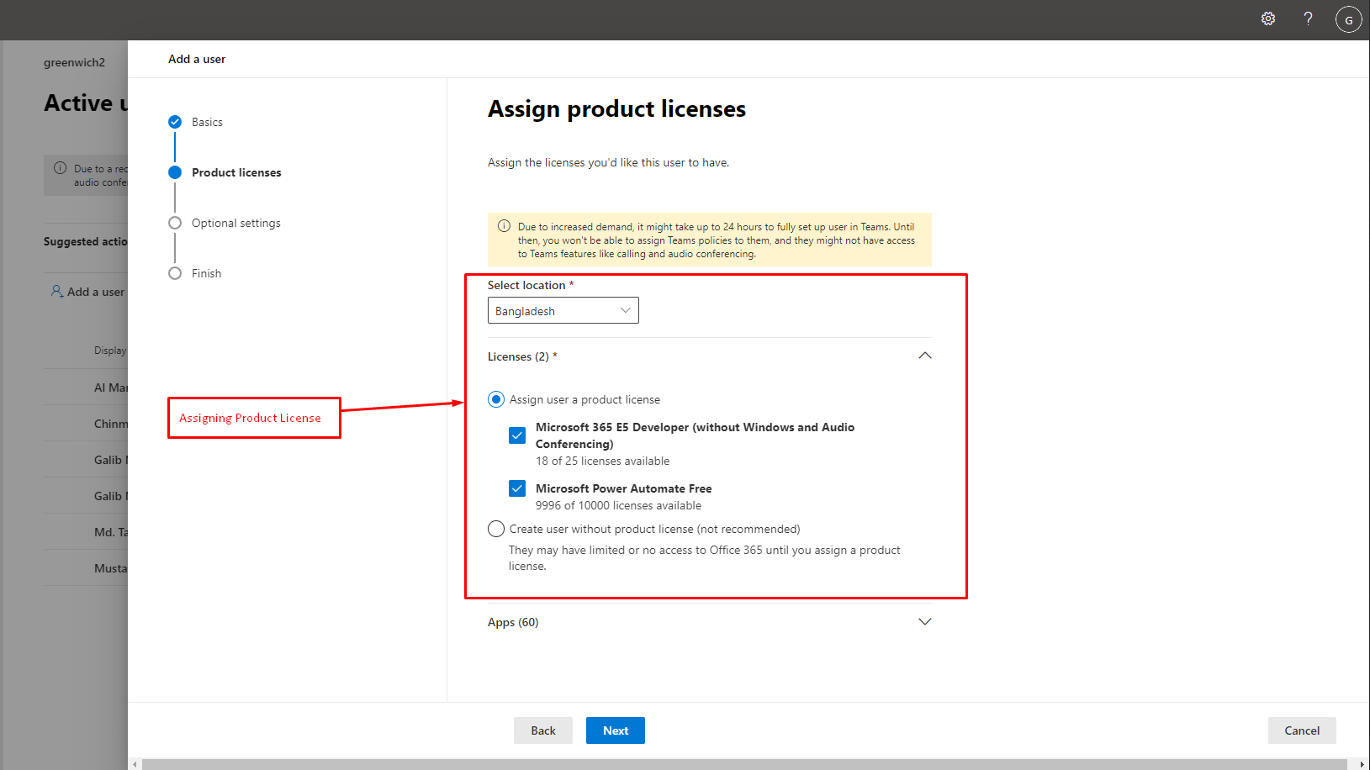

Figure 30: Applying license.

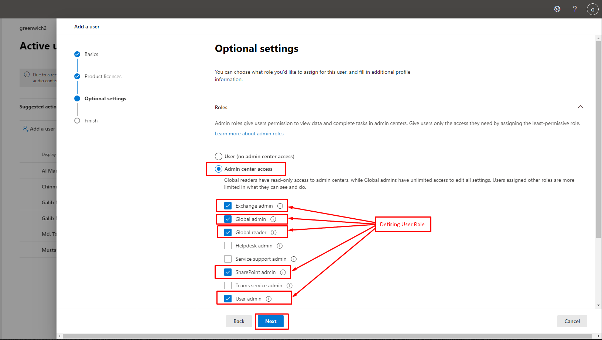

Figure 31: Assigning role.

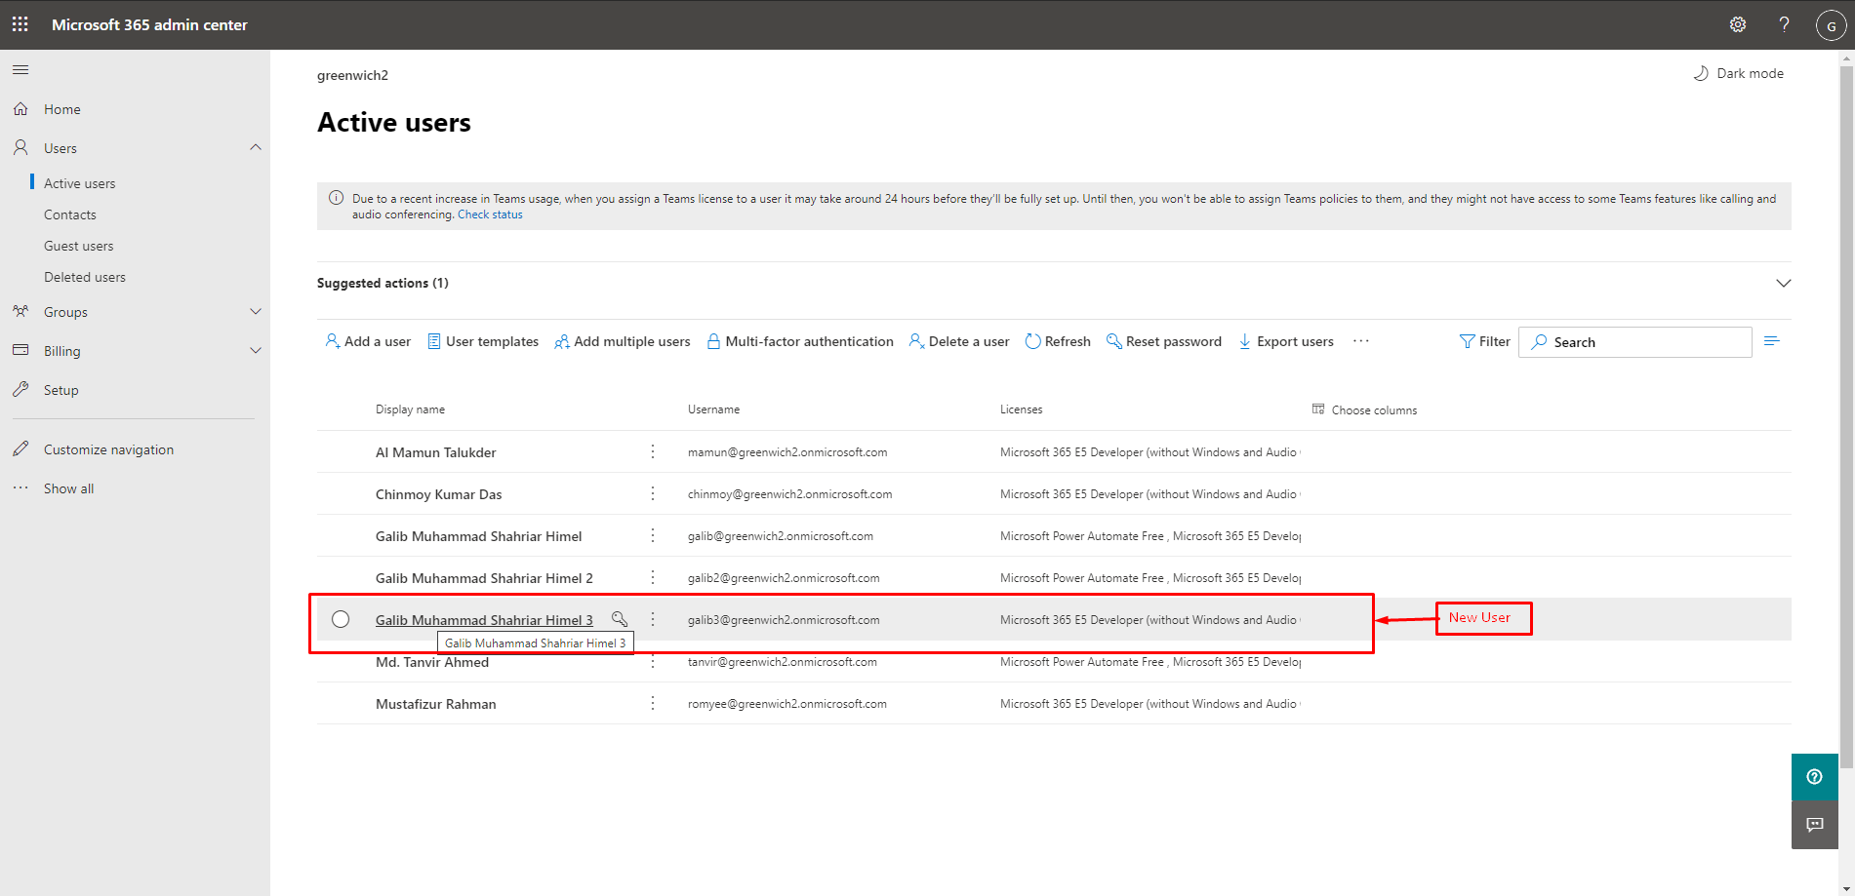

Figure 32: User added successfully.

**6. Creating a workflow**

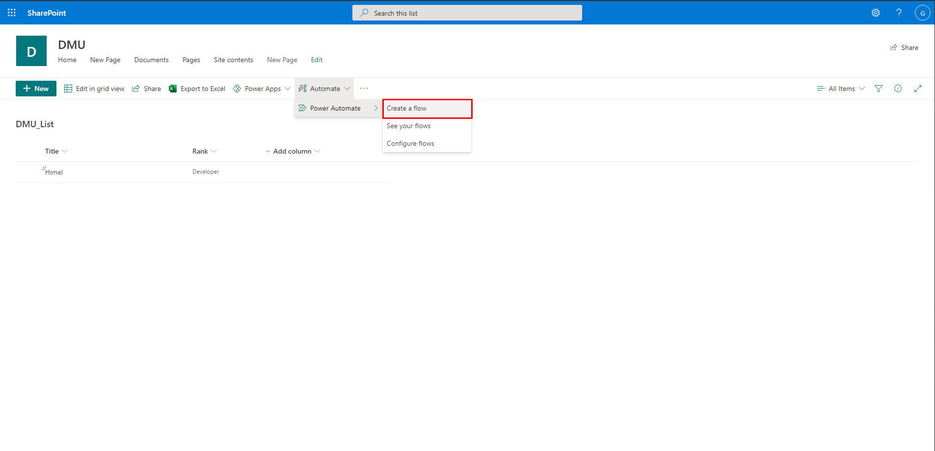

Figure 33: Create work flow.

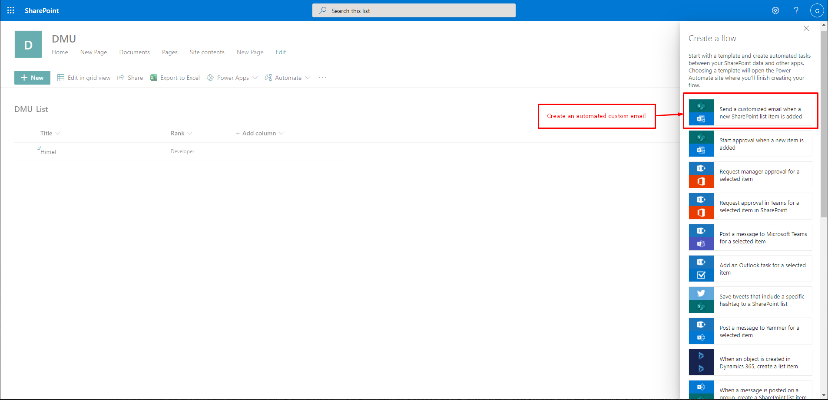

Figure 34: Create automated custom email.

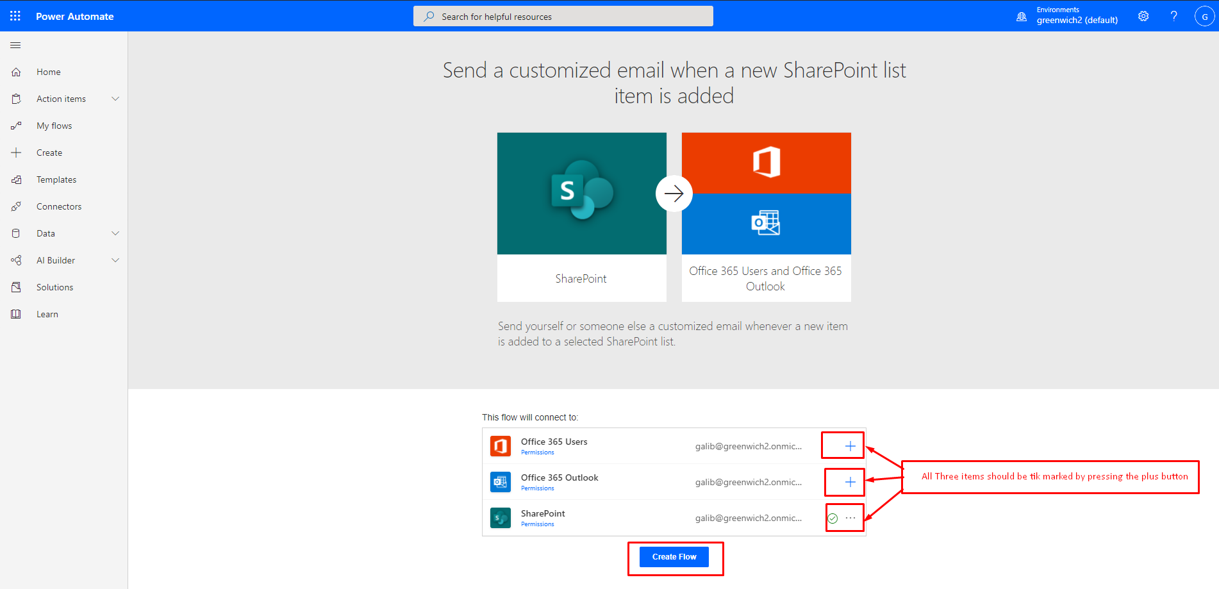

Figure 35: Mark all options.

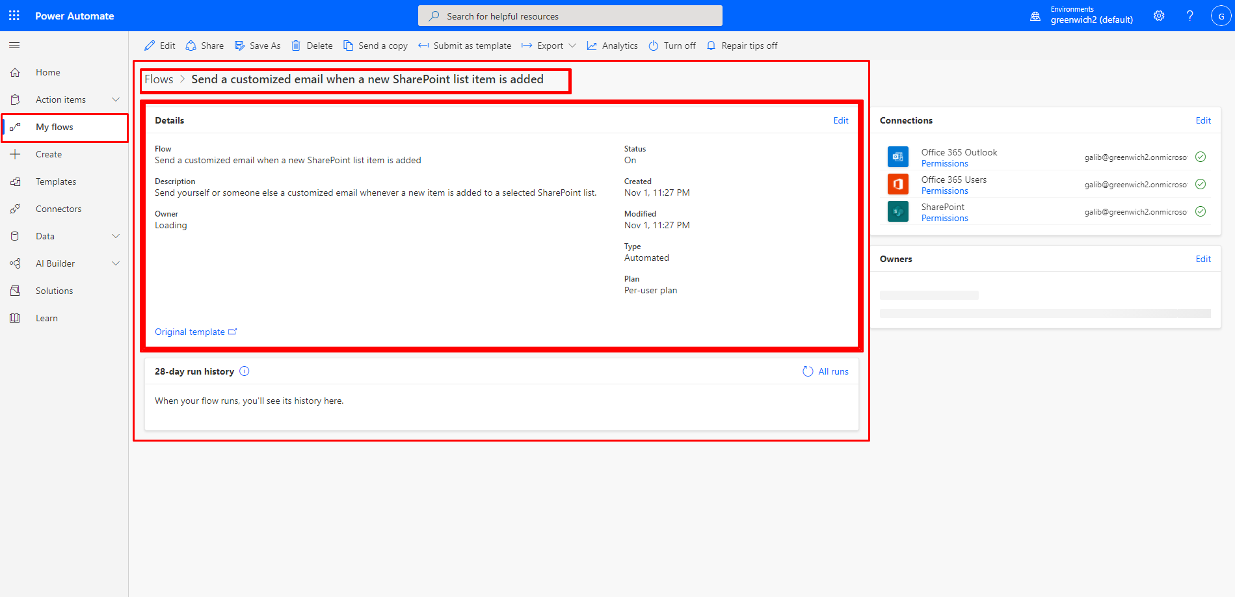

Figure 36: New Work Flow created.

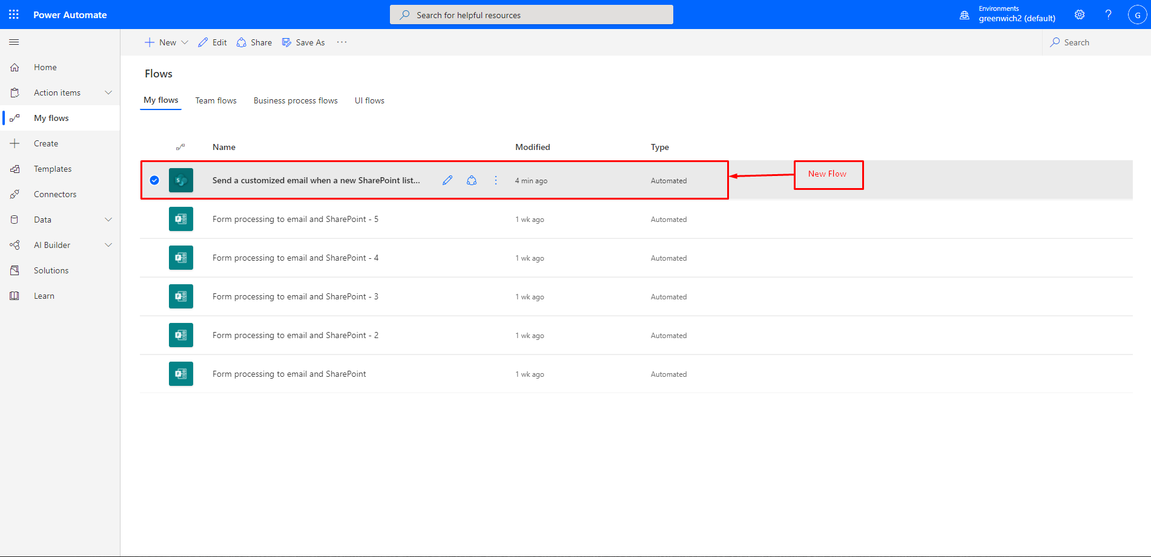

Figure 37: Check Flow list.

**8.2 Appendix B: Developers artifacts**

Course Pages:

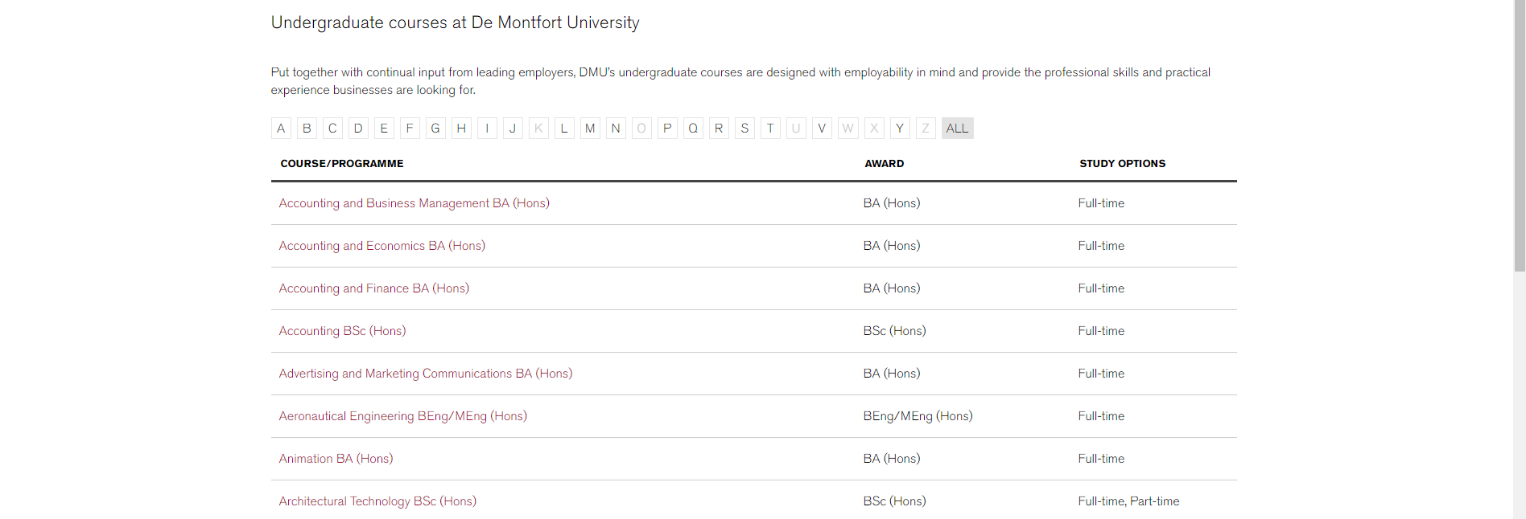

Figure 38: Undergraduate course (original).

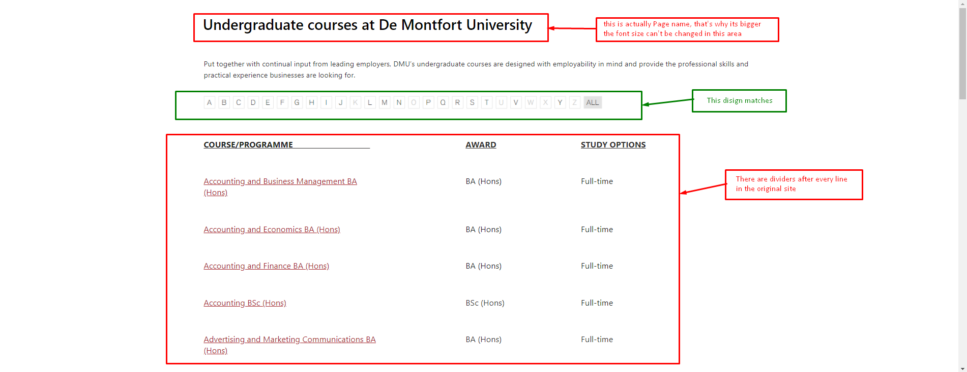

Figure 39: Undergraduate course (CMS).

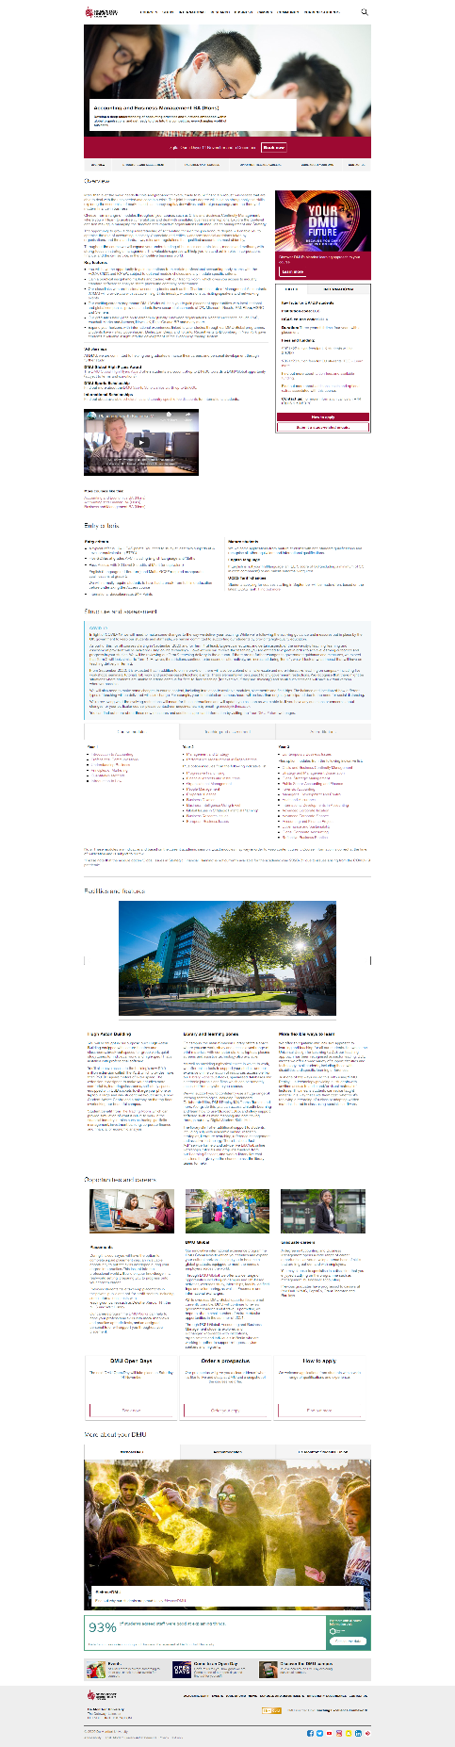

Figure 40: Accounting and Business Management (original).

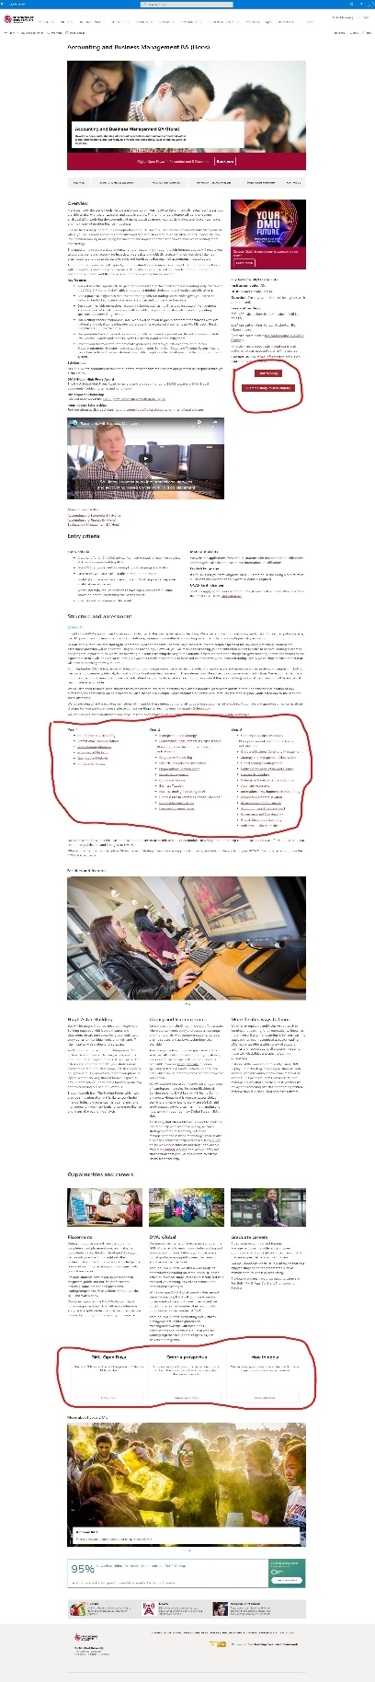

Figure 41: Accounting and Business Management (CMS).



Figure 42: Accounting and Business Management -1 (original).

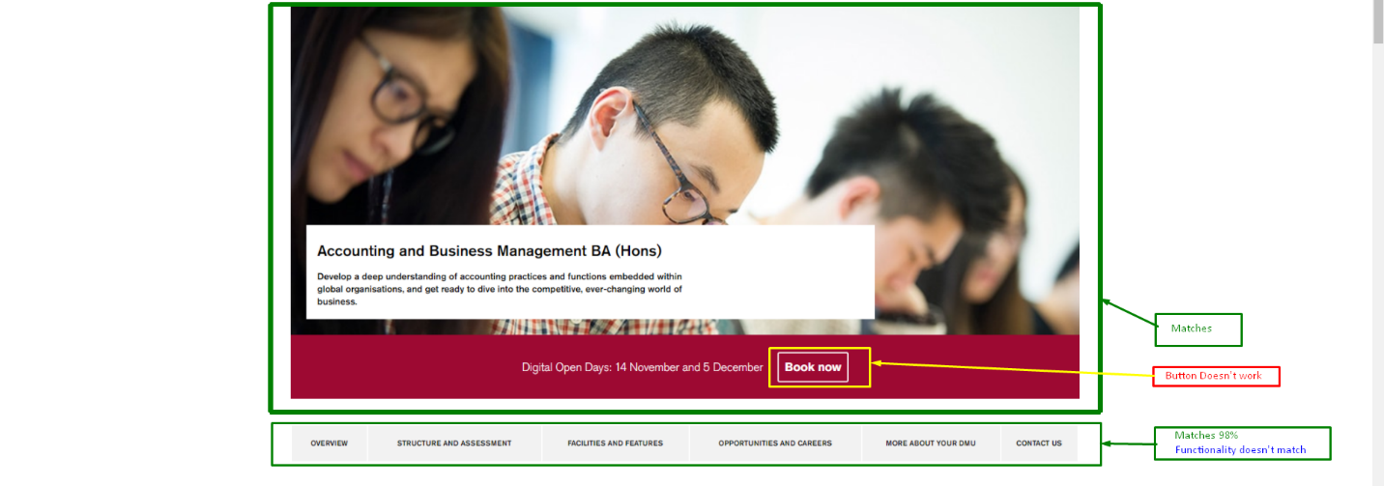

Figure 43: Accounting and Business Management -1 (CMS).

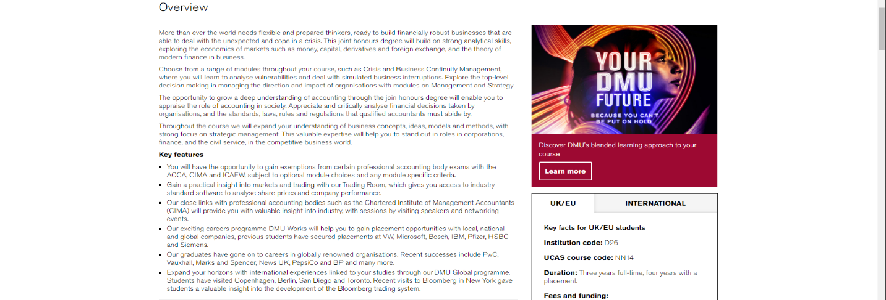

Figure 44: Accounting and Business Management -2 (original).

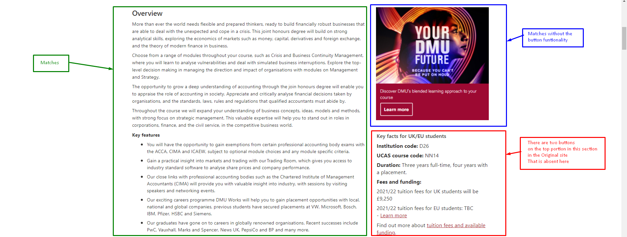

Figure 45: Accounting and Business Management -2 (CMS).

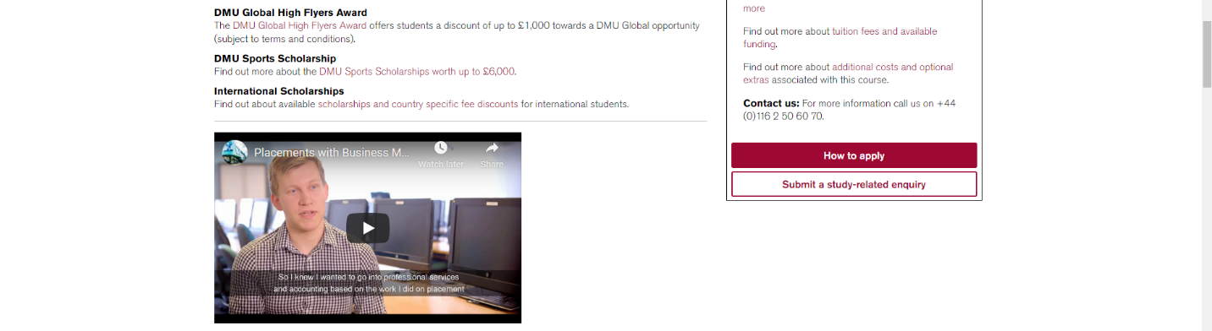

Figure 46: Accounting and Business Management -3 (original).

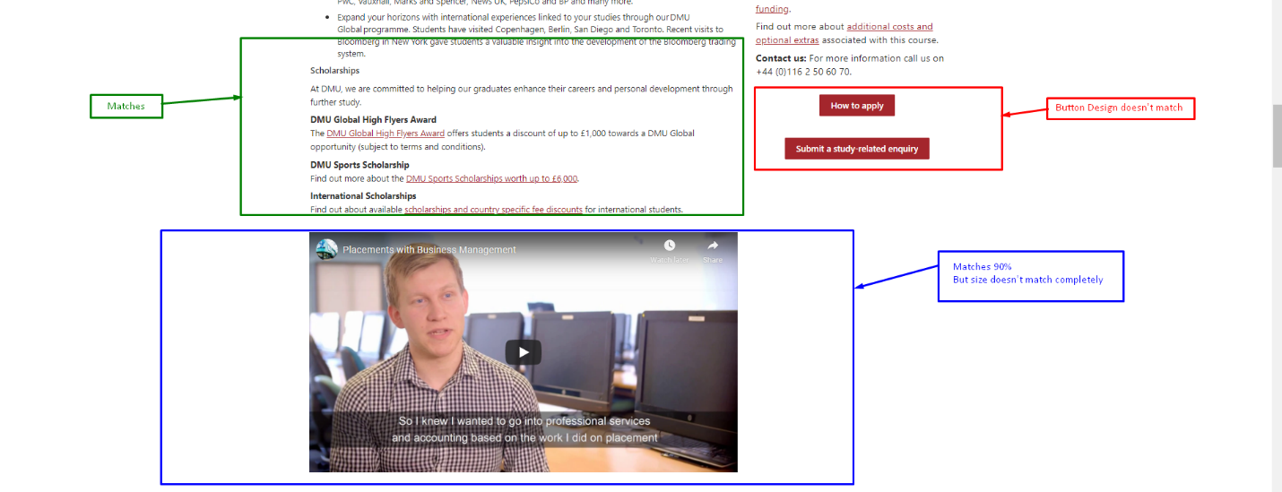

Figure 47: Accounting and Business Management -3 (CMS).

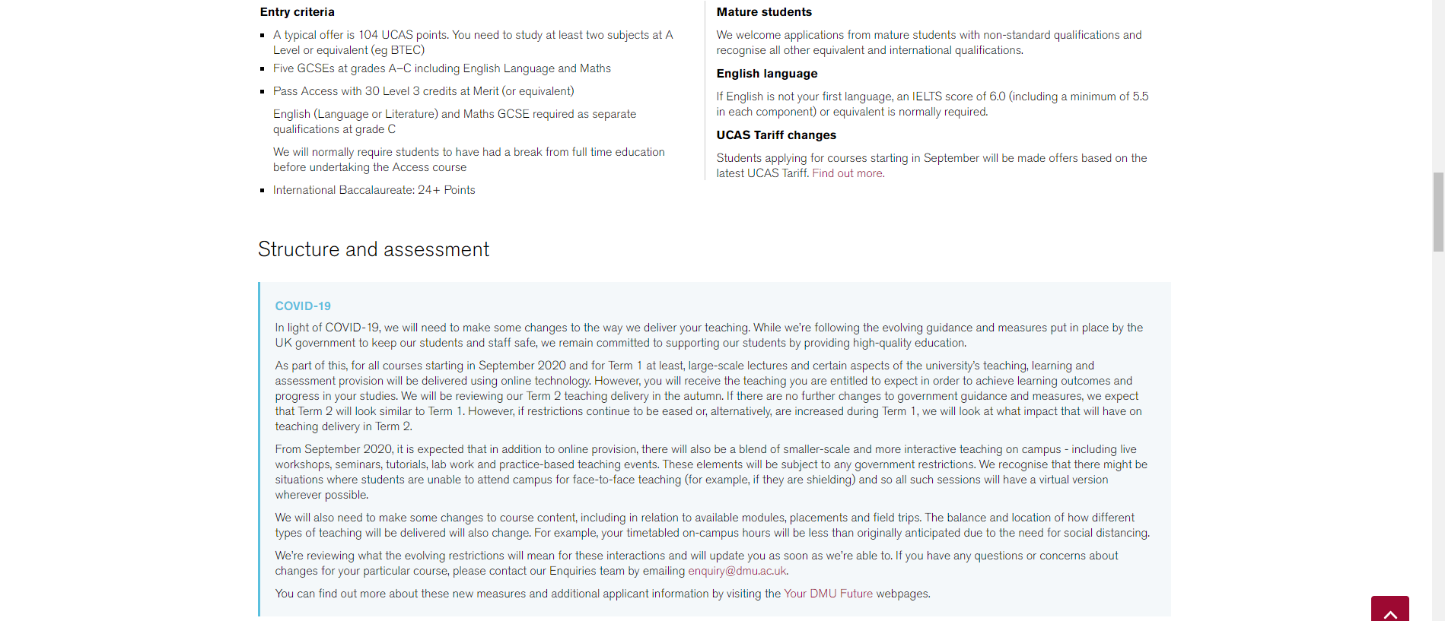

Figure 48: Accounting and Business Management -4 (original).

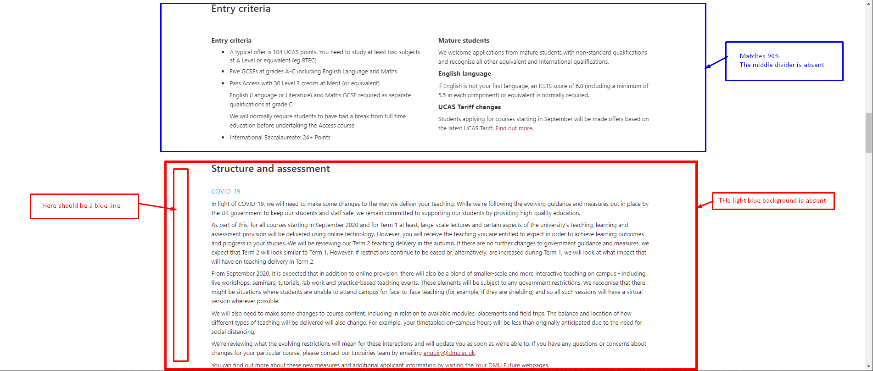

Figure 49: Accounting and Business Management -4 (CMS).

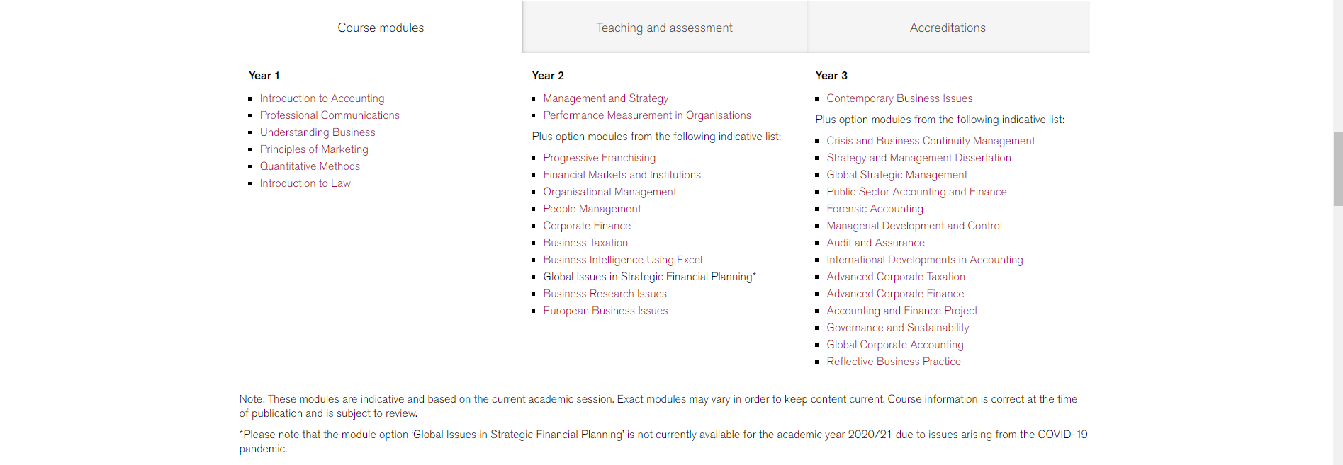

Figure 50: Accounting and Business Management -5 (original).

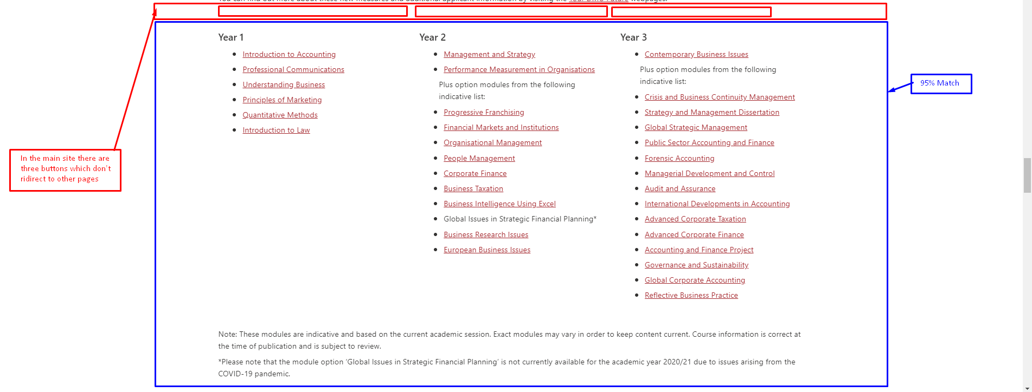

Figure 51: Accounting and Business Management -5 (CMS).

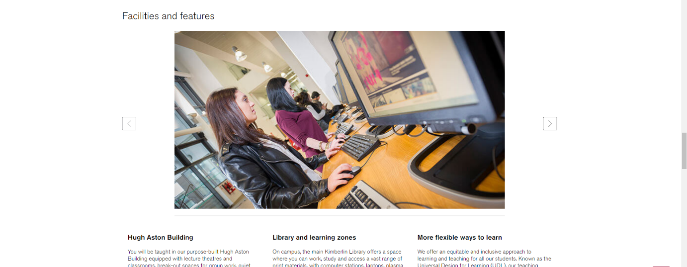

Figure 52: Accounting and Business Management -6 (original).

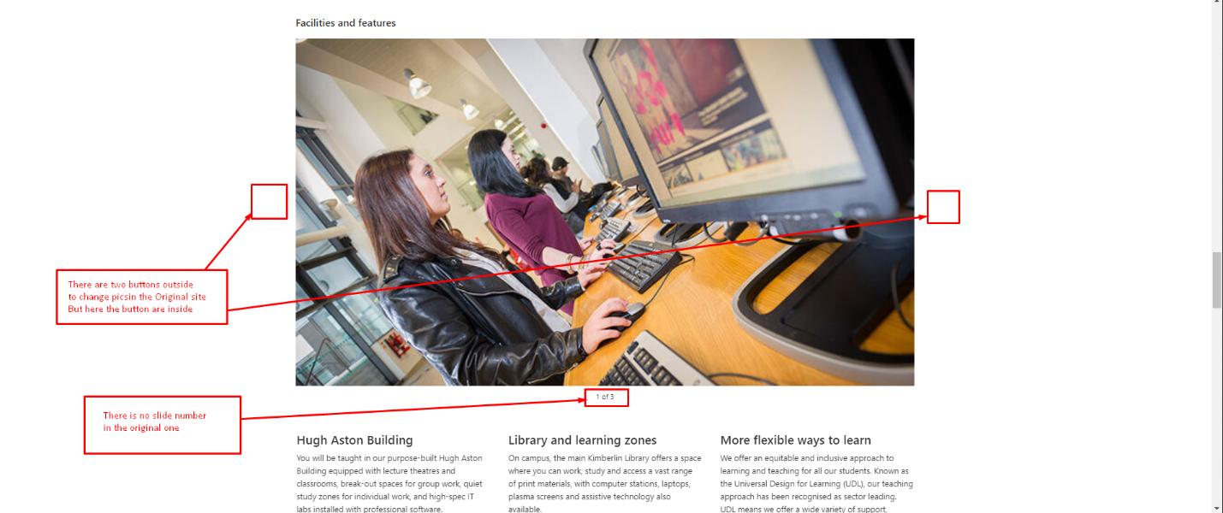

Figure 53: Accounting and Business Management -6 (CMS).



Figure 54: Accounting and Business Management -7 (original).

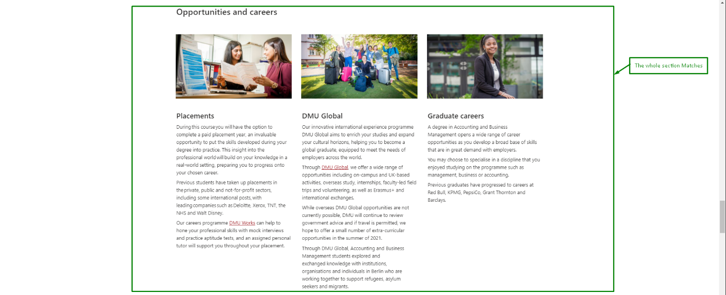

Figure 55: Accounting and Business Management -7 (CMS).

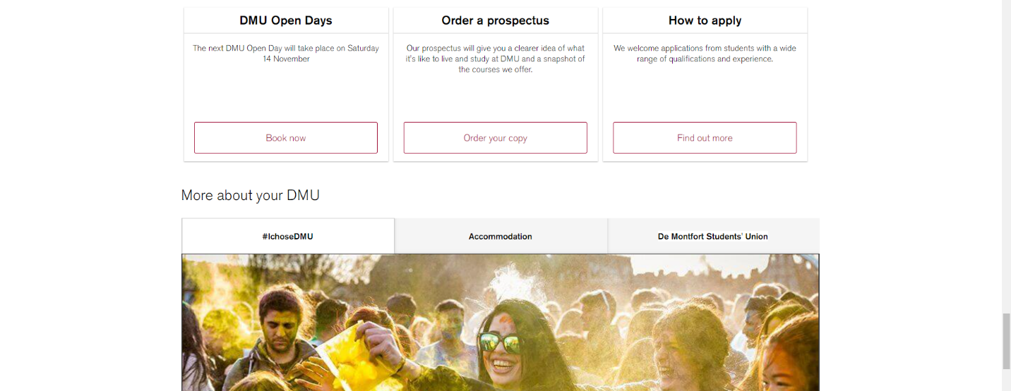

Figure 56: Accounting and Business Management -8 (original).

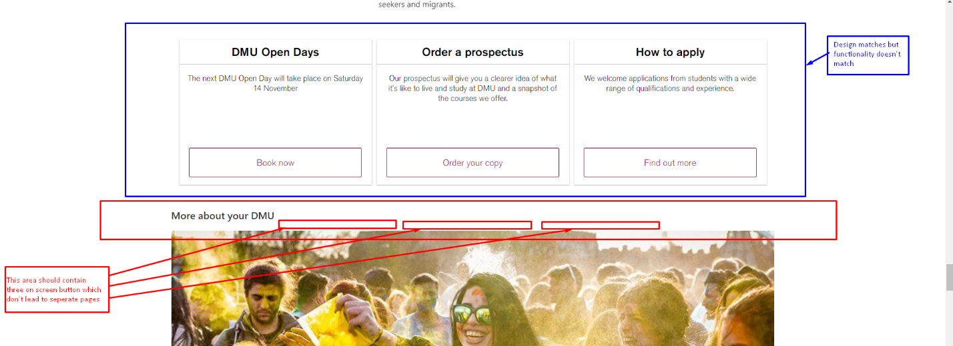

Figure 57: Accounting and Business Management -8 (CMS).



Figure 58: Accounting and Business Management -9 (original).

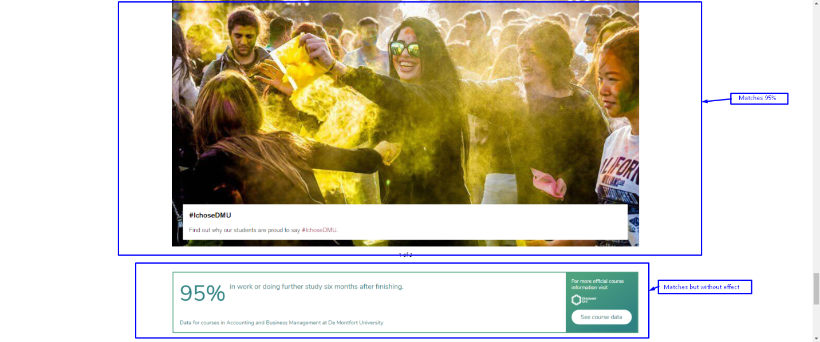

Figure 59: Accounting and Business Management -9 (CMS).

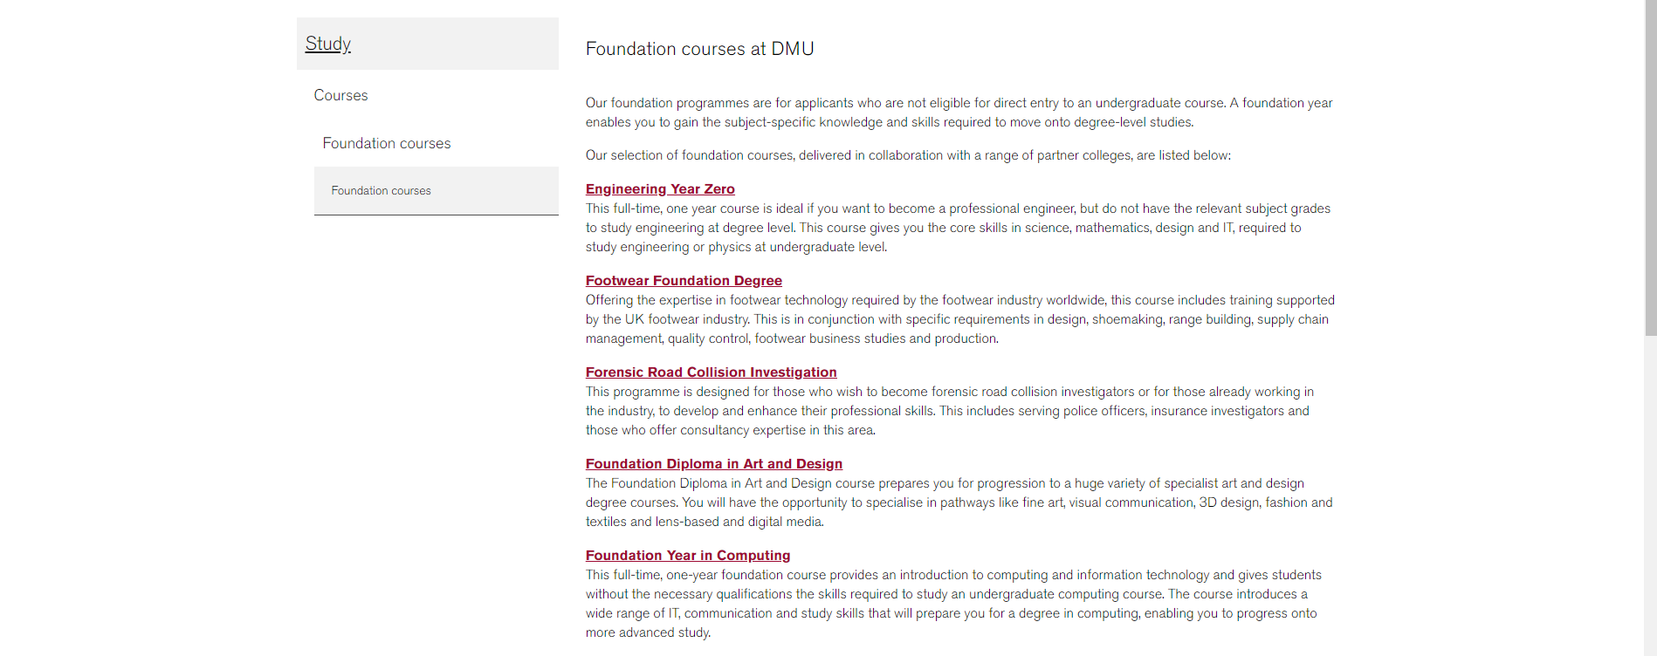

Figure 60: Foundation course (original).

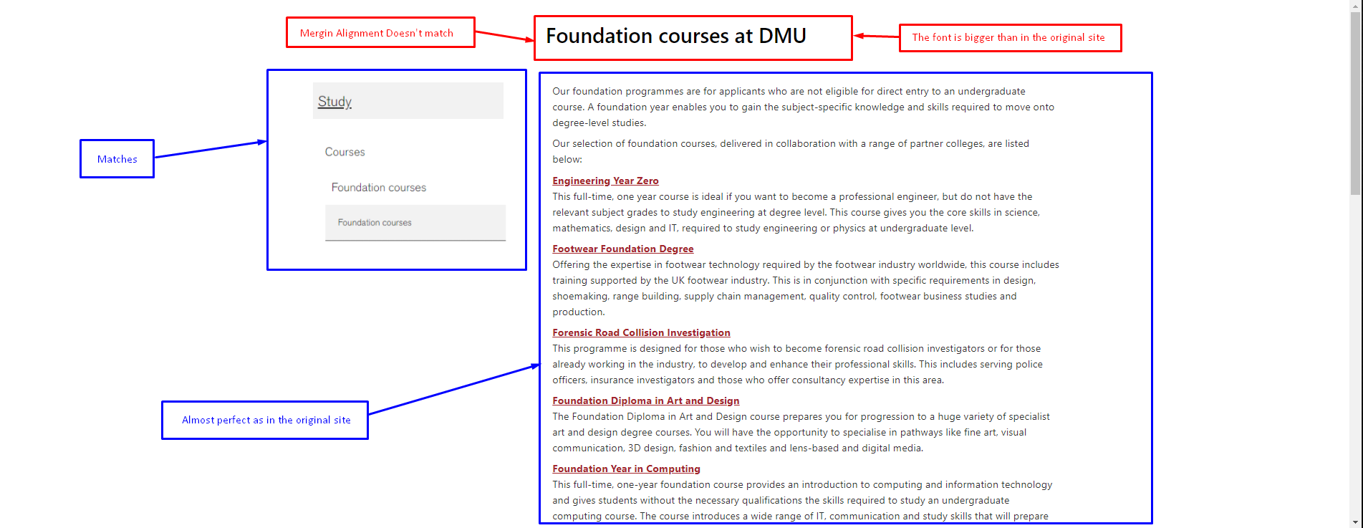

Figure 61: Foundation course (CMS).

Research centre page:

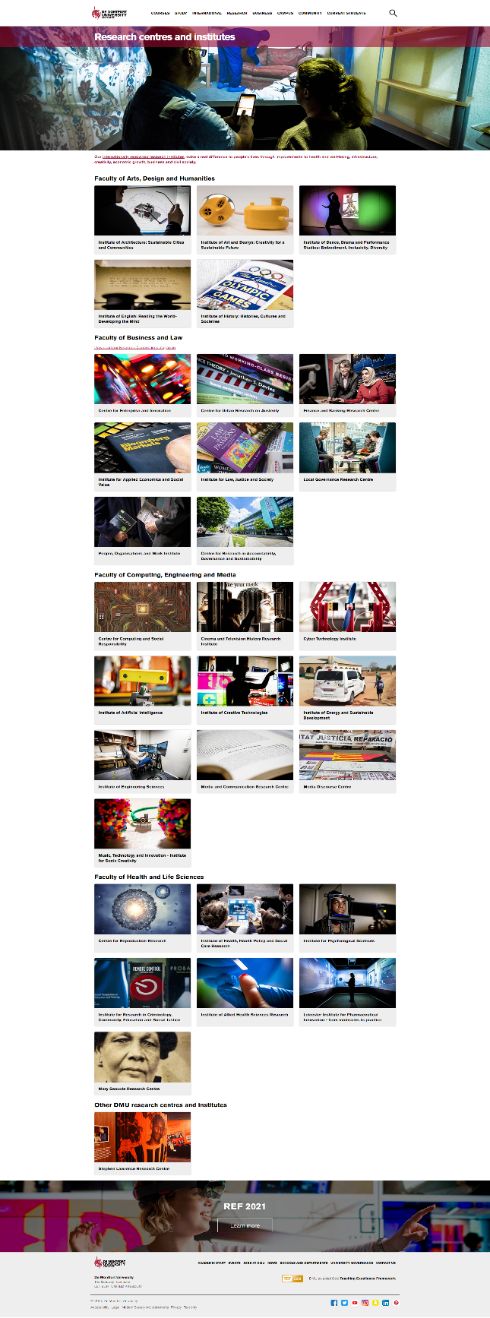

Figure 62: Research centre (original).

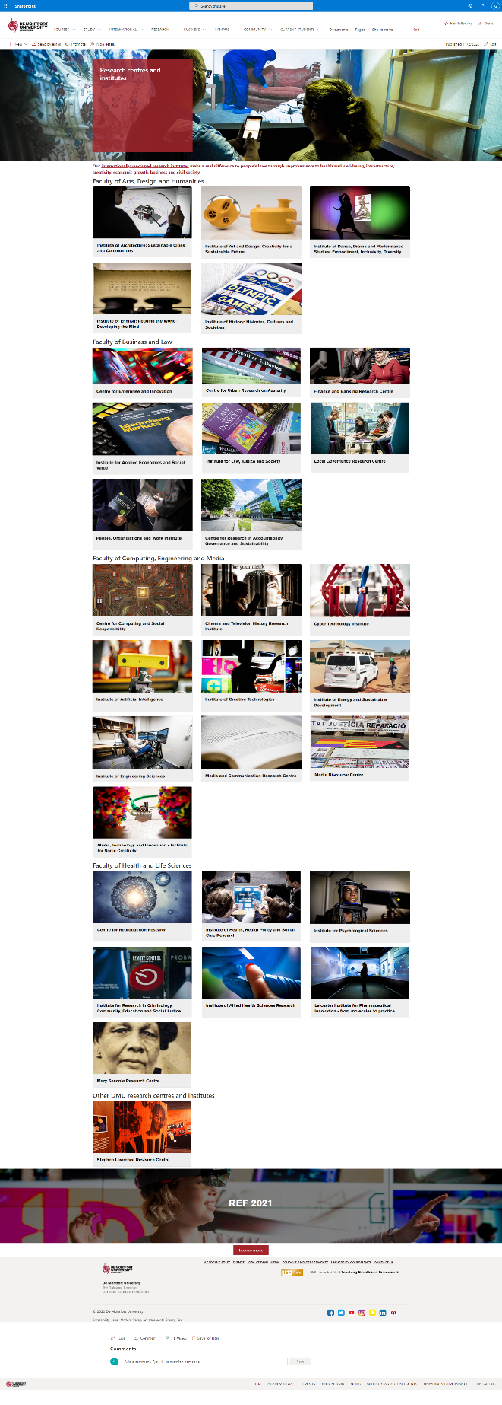

Figure 63: Research centre (CMS).

News pages:

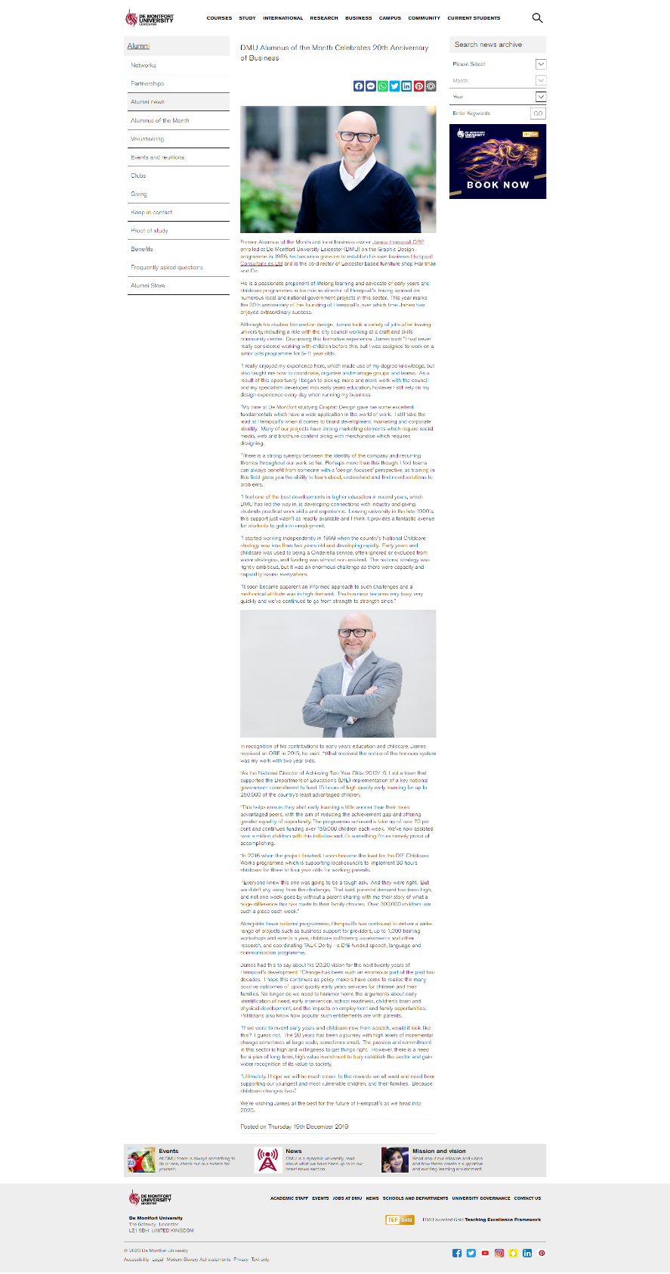

Figure 64: News2 (original).

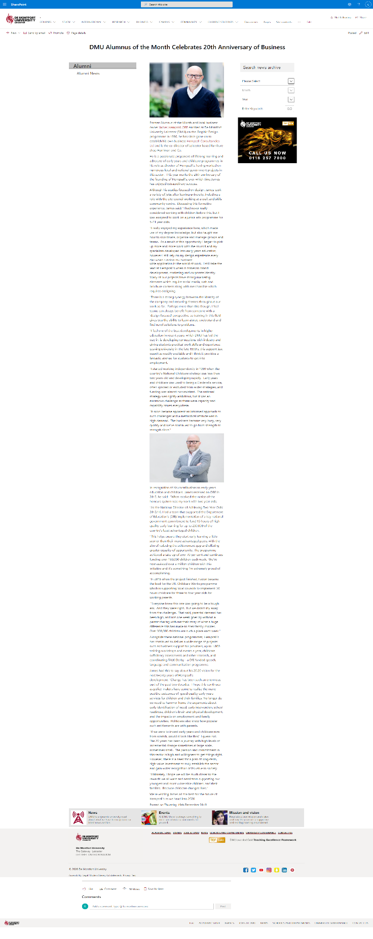

Column width mismatched which can’t be fixed because there no options for such edit.

Side bar is not developed.

Figure 65: News2 (CMS).

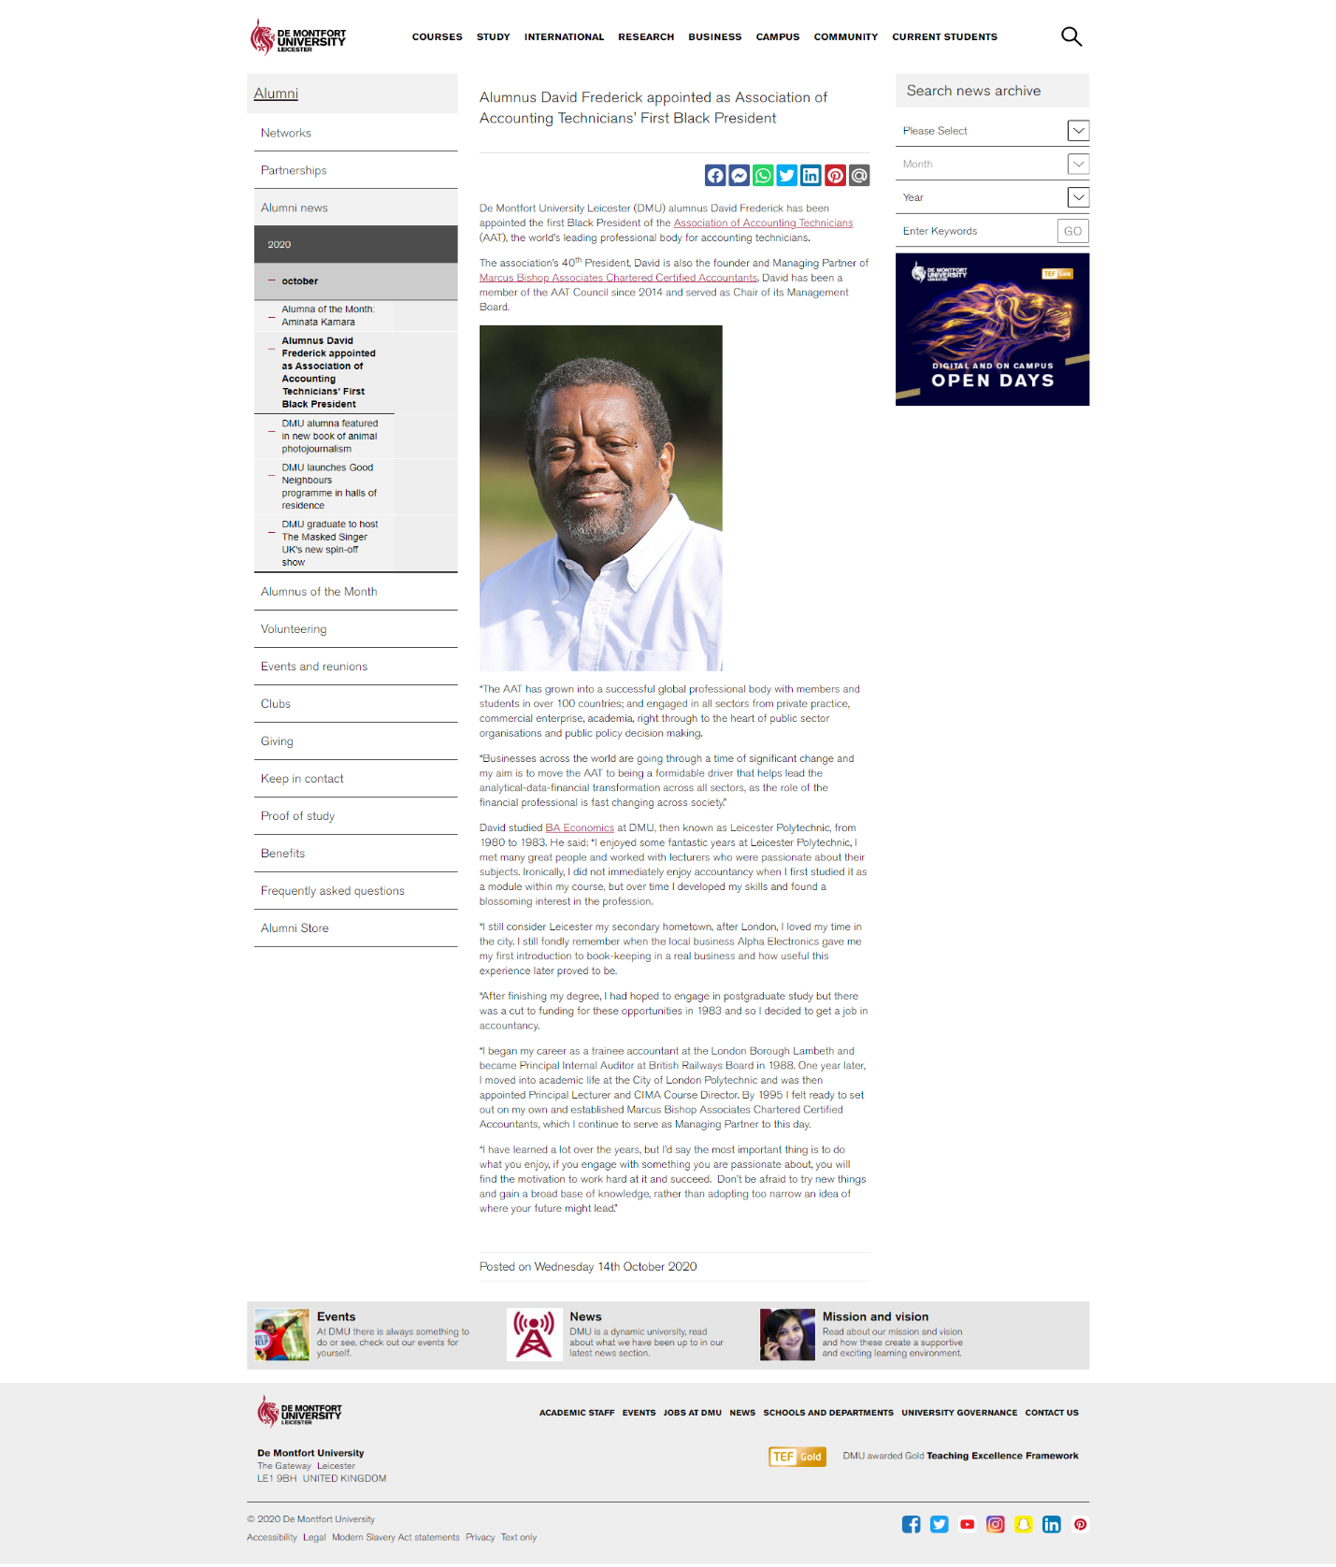

Figure 66: News3 (original).

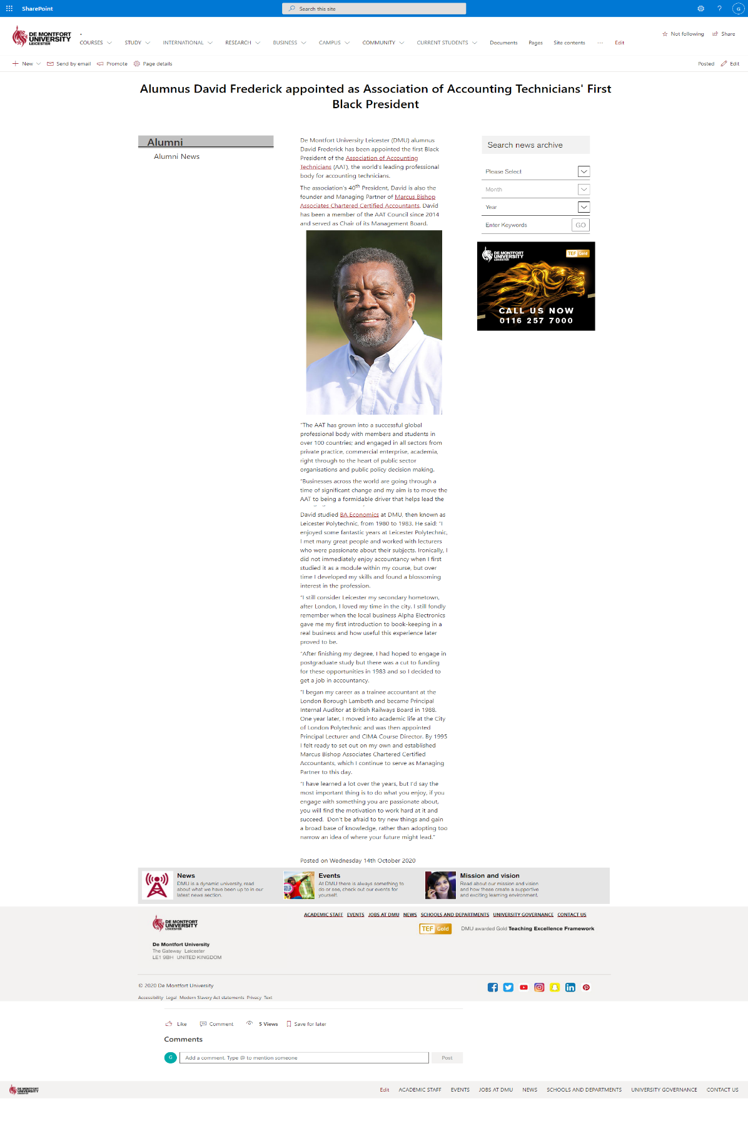

Social icon can’t be added like in the original.

Here is major mismatch in left side bar. Not every news page side bar is like this. Only this one is completely unique, which can’t be developed using modern SharePoint

Figure 67: News3 (CMS).

Pages related to contact details:

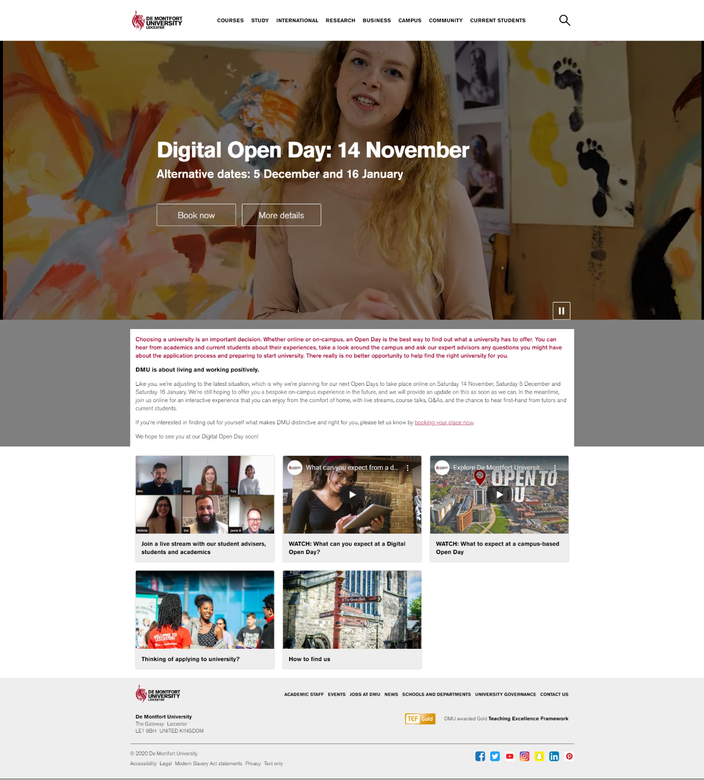

Figure 68: Digital open day(original).

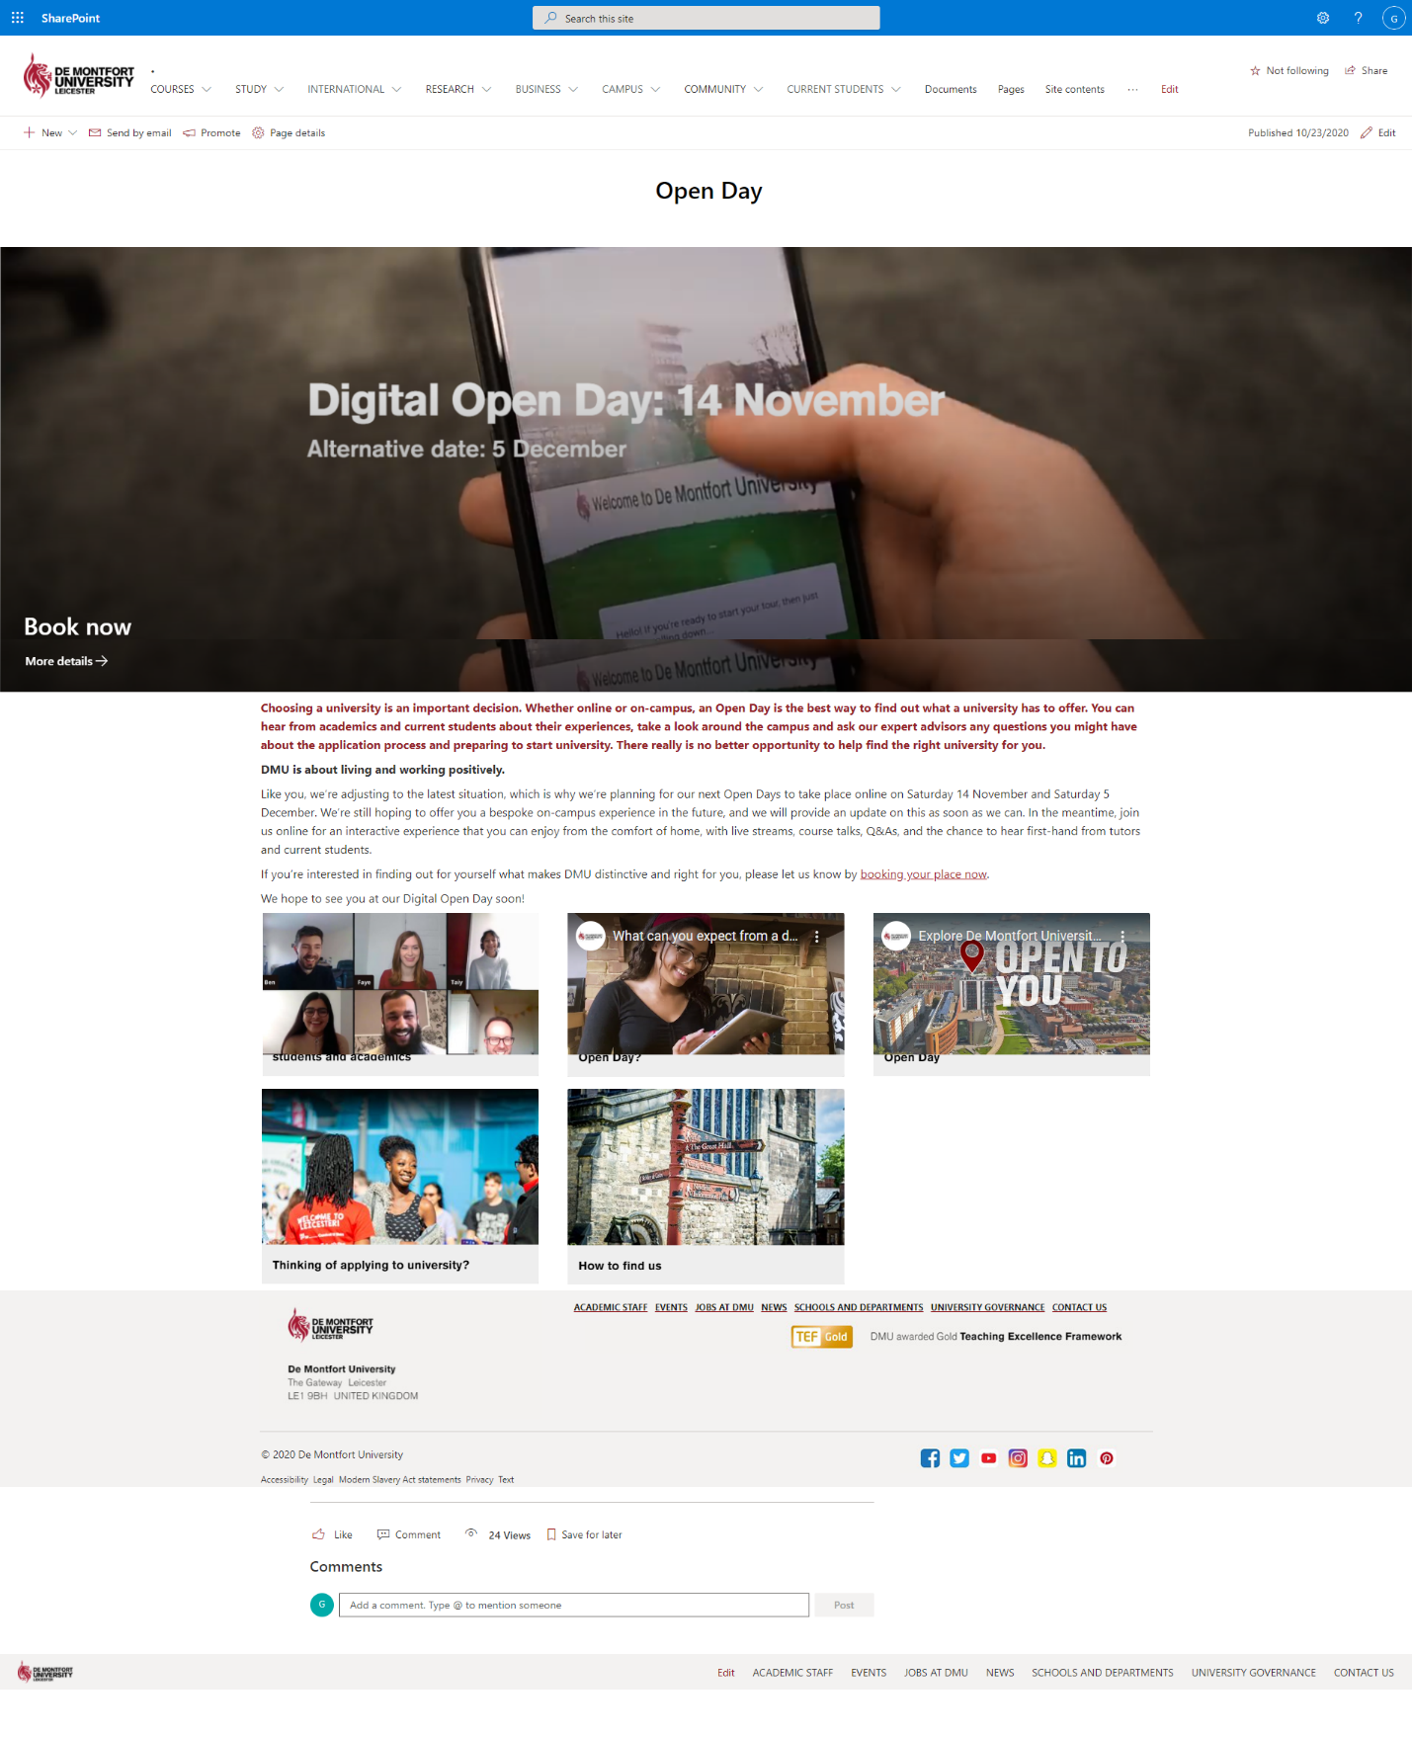

Overlapping is not available in hero

Video can’t be embedded in this hero section using CMS

Figure 69: Digital open day(CMS).

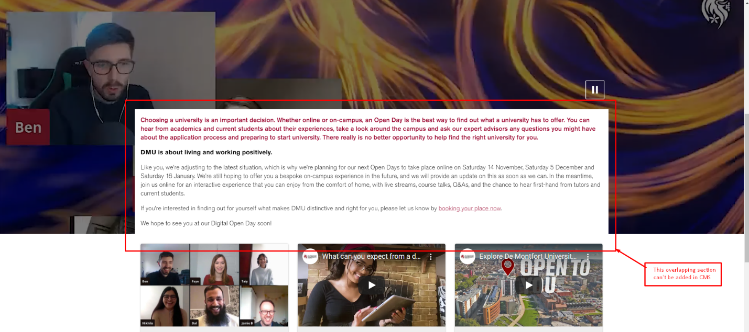

Figure 70: Digital open day (CMS partial).

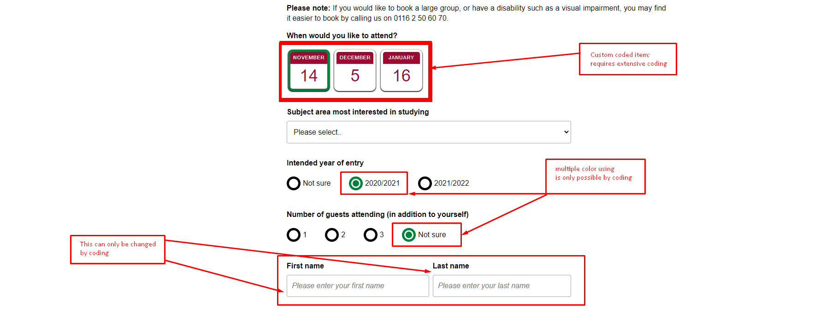

Figure 71: Undergraduate open day booking(original).

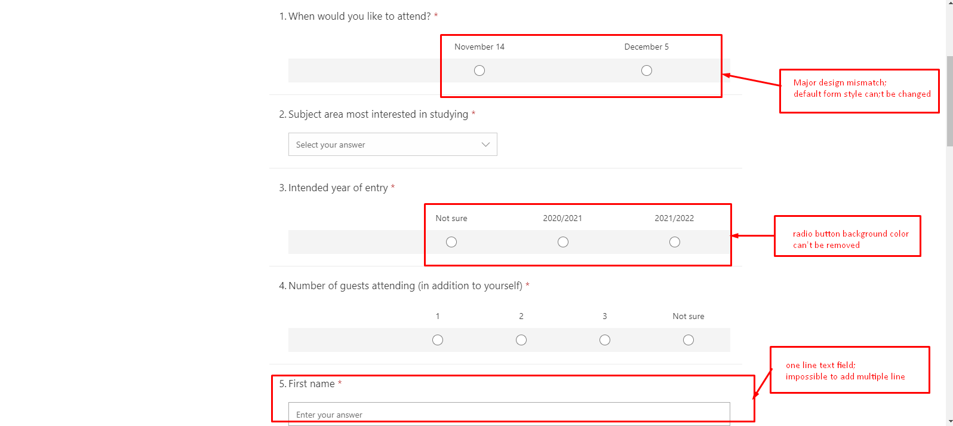

Figure 72: Undergraduate open day booking(CMS).

Study page:

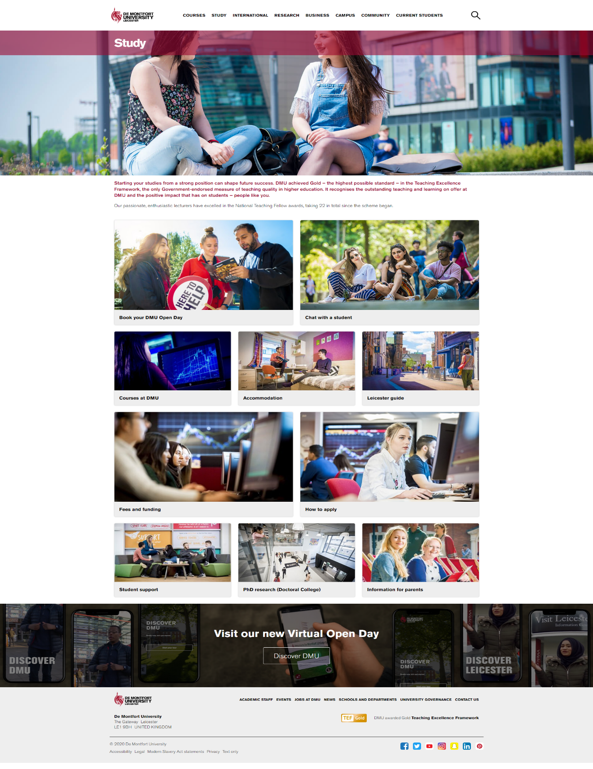

Figure 73: Study page (original).

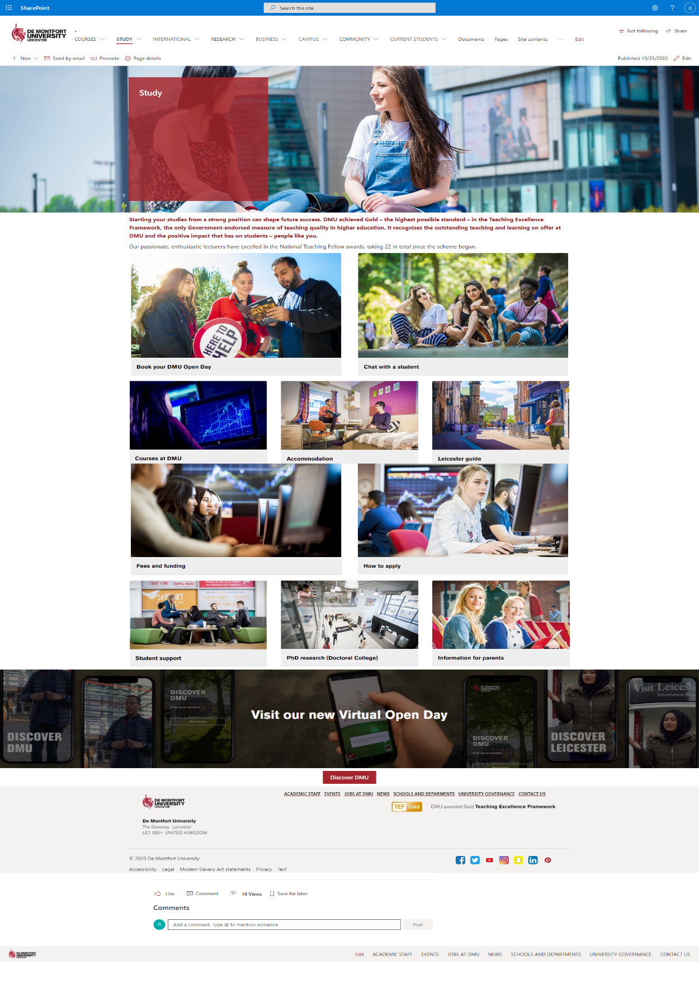

Button position and style mismatch.

Default design can’t be altered.

Figure 74: Study page (CMS).

About page:

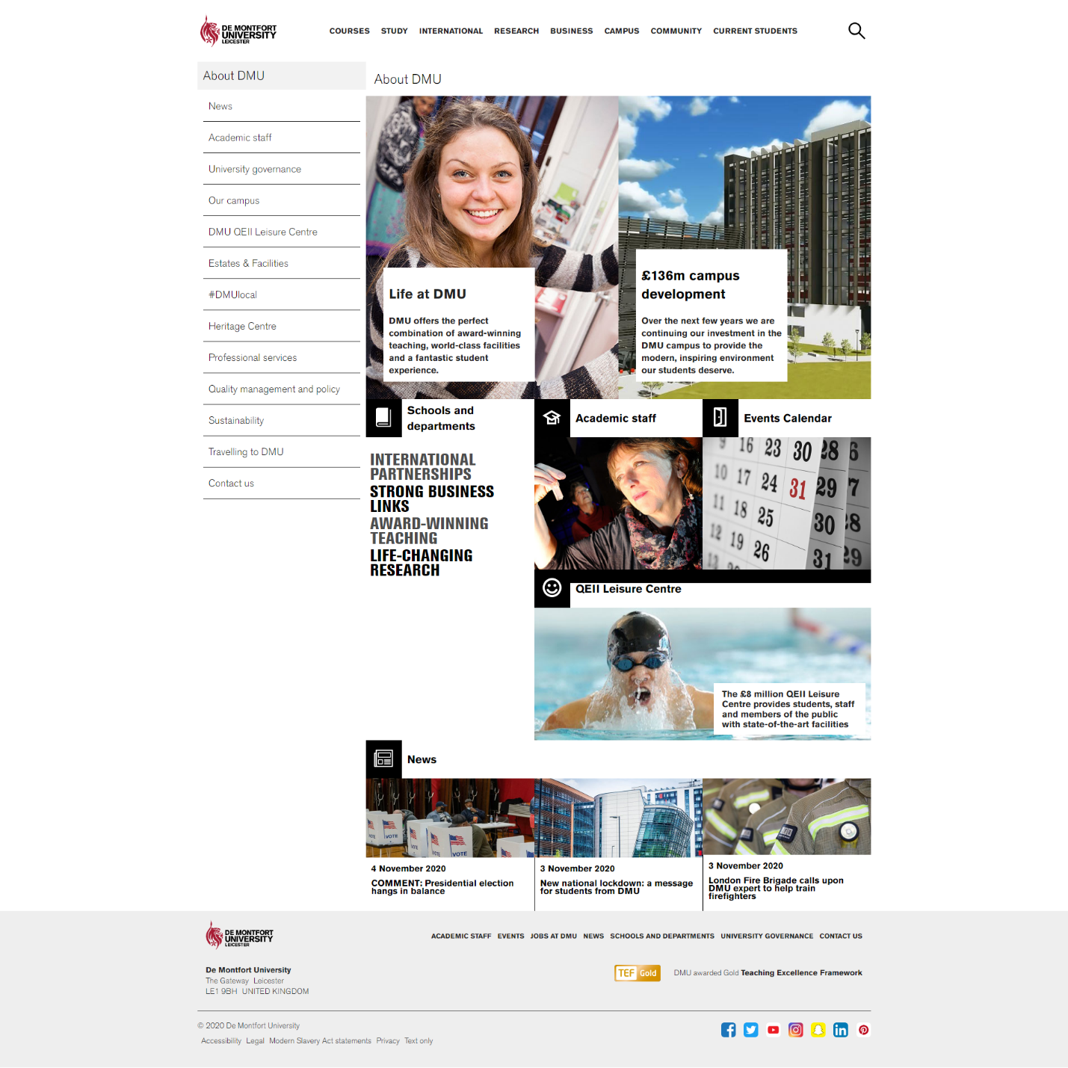

Figure 75: About page (original).

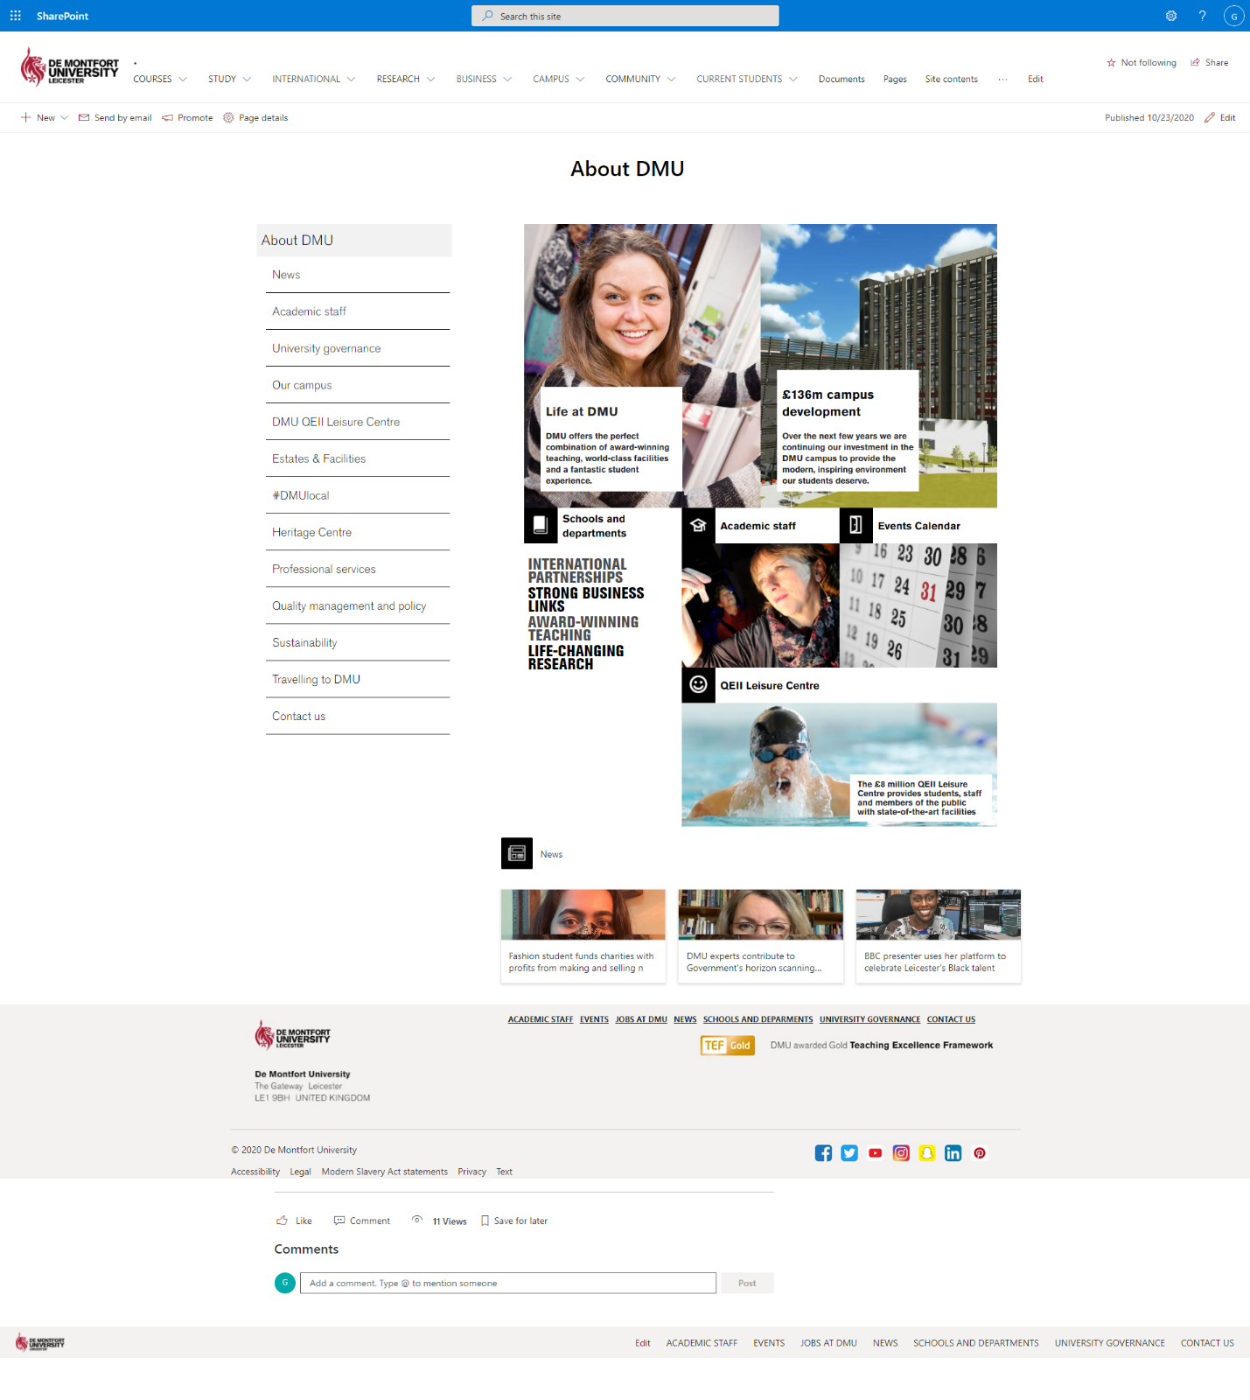

Matches 90%.

Figure 76: About page (CMS).

**8.3 Appendix C: Database functionalities**

We are using ‘Undergraduate open day booking form’ for database testing.

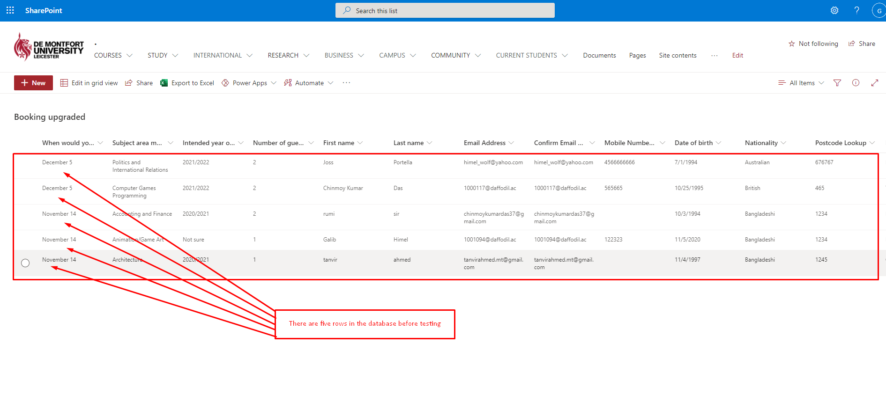

Figure 77: Database before inserting data.

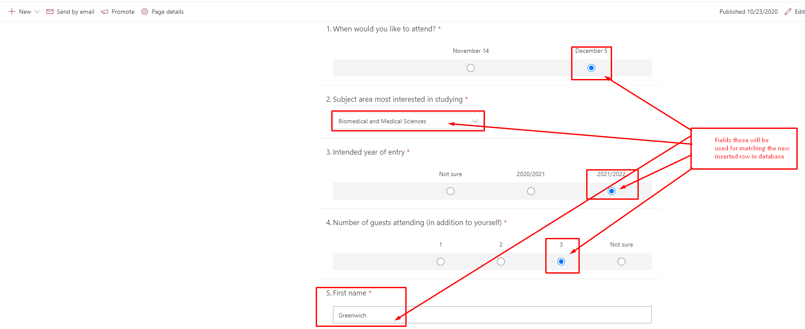

Figure 78: inserting data into the form.

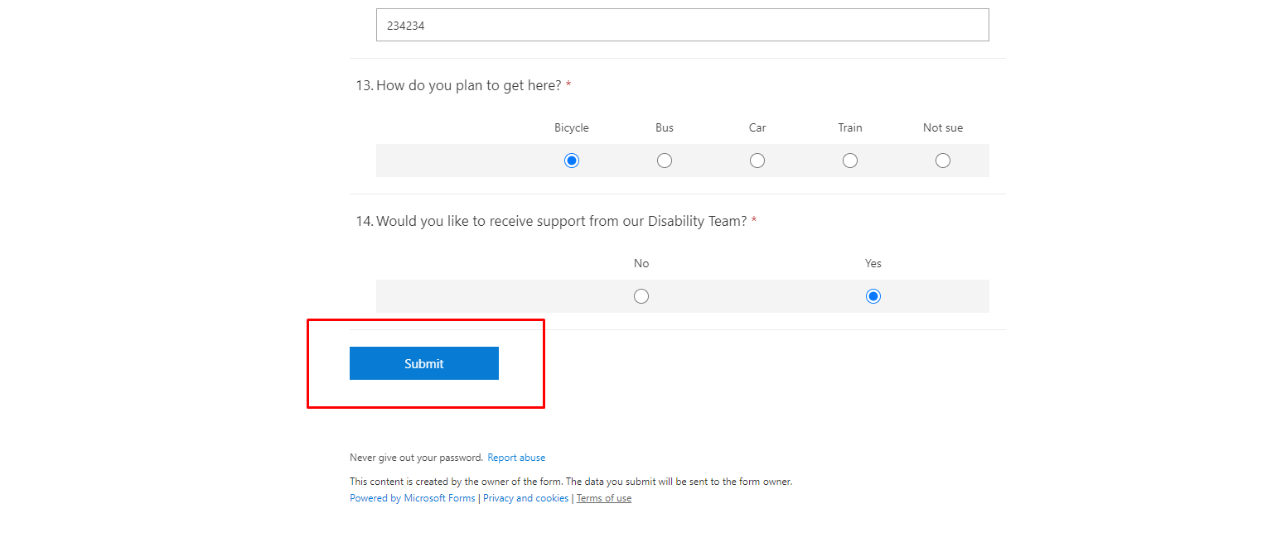

Figure 79: Before clicking submit button.

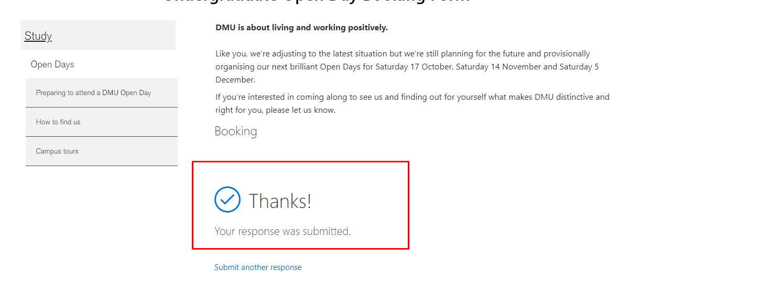

Figure 80: After clicking submit button.

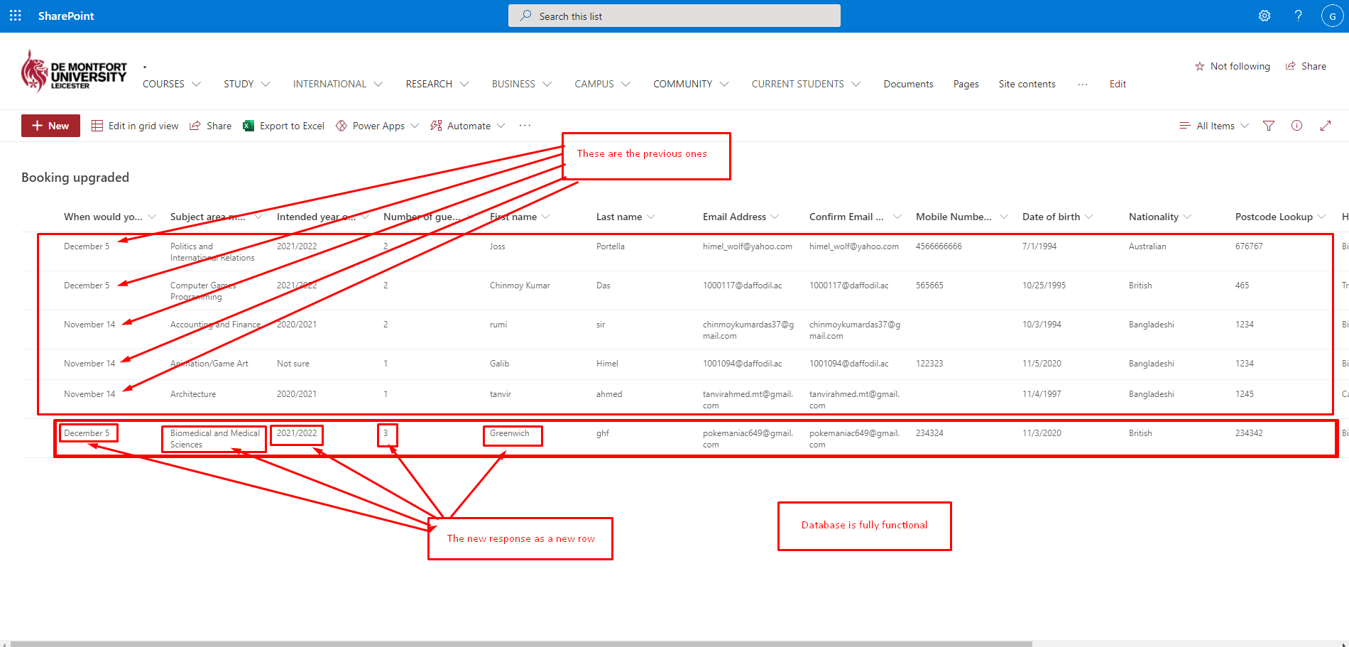

Figure 81: New row added as data inside database.

**8.4 Appendix D: Work flow**

We are using ‘study related Enquiry’ for testing workflow.

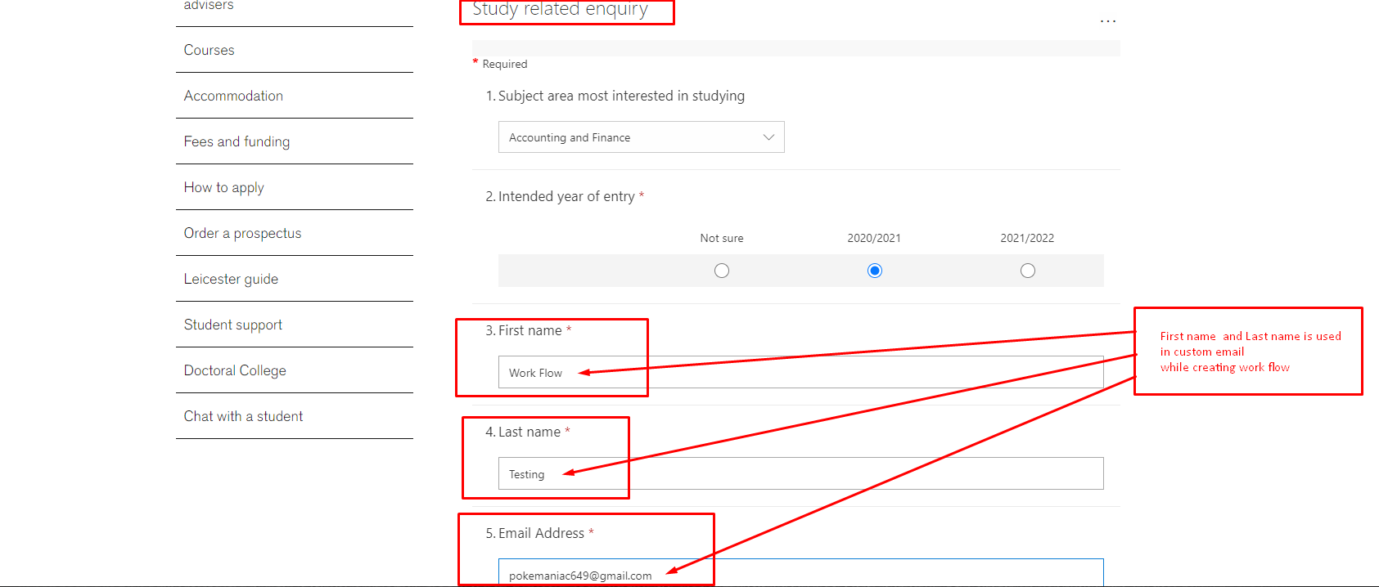

Figure 82: Before entering data in the form.

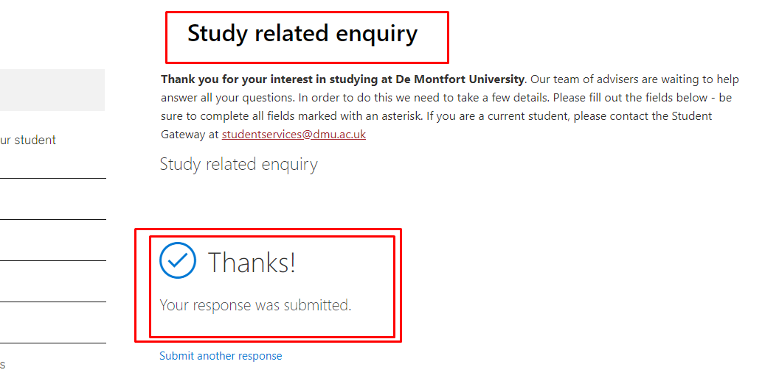

Figure 83: Response was submitted.

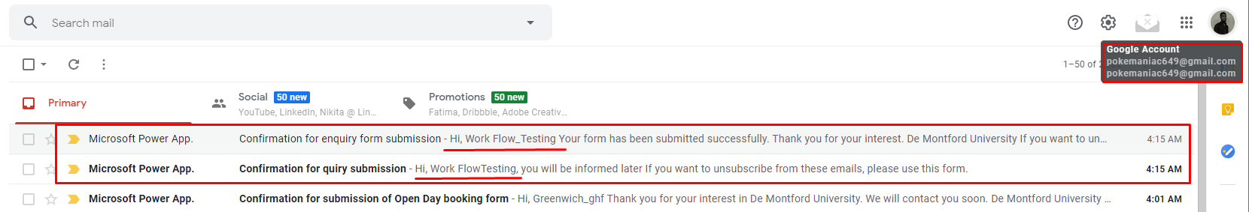

Figure 84: Email was received.

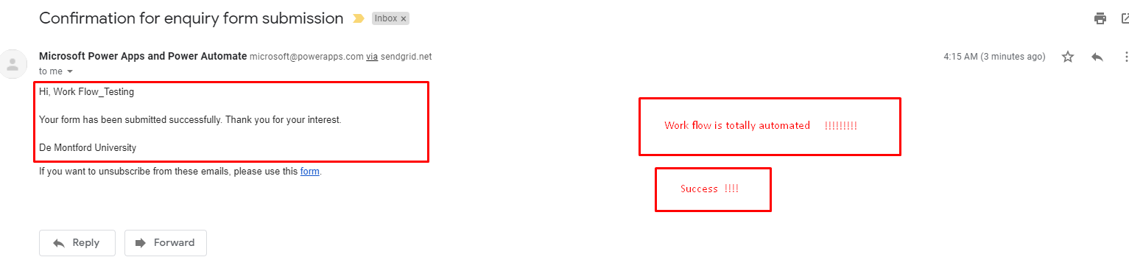

Figure 85: Work Flow was created successfully.

Both Database and work Flow is working perfectly.